Implementation
- Using layers
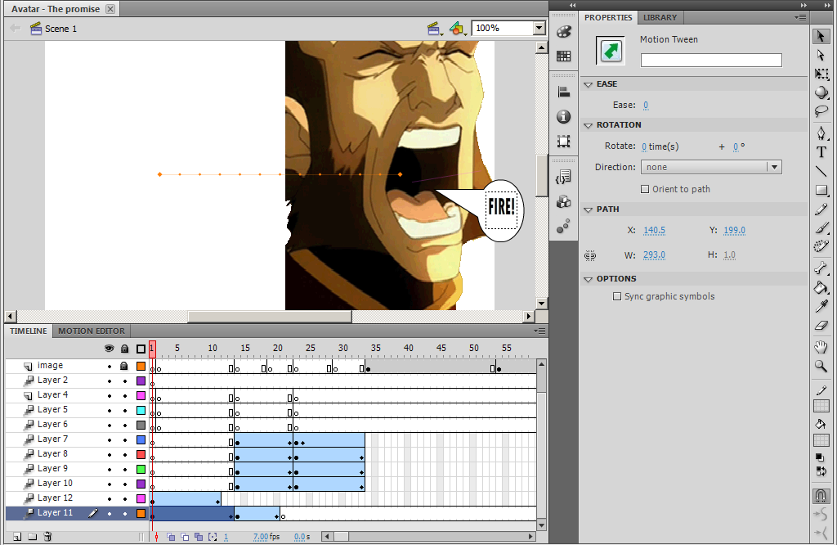
Whilst creating my game in Adobe Flash Professional, I had to use some layers in order to be able to create motion and shape tweens. I have also decided to use layers in my animation simply to be able to place specific items on top of each other or below. In the image above, the picture is placed on “layer 11” and the speech bubble reading “FIRE!” is on layer 12. I decided to separate these two because they both contain different motion tweens, and because the speech bubble is placed on top of the image.
- Using Onion skin
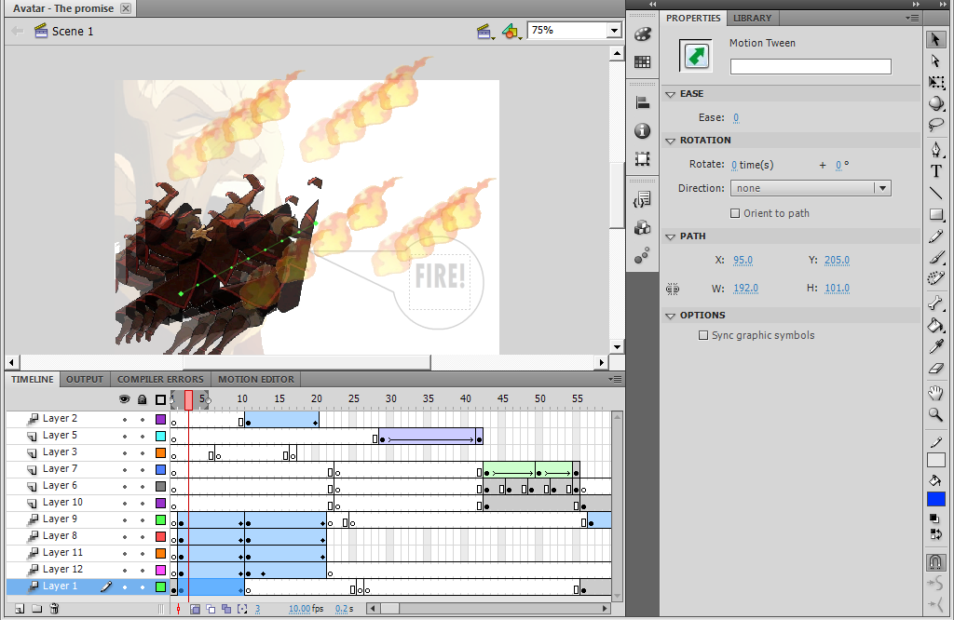
The onion skin was a very useful tool that I was able to use in my animation for the use of moving and placing items that are identical to each other from another frame, and being able to place them exactly where they are in that other frame. In the image above this is being demonstrated as I can see clearly where the object will start and finish at the end of the tween.
- Using Shape/Motion tween
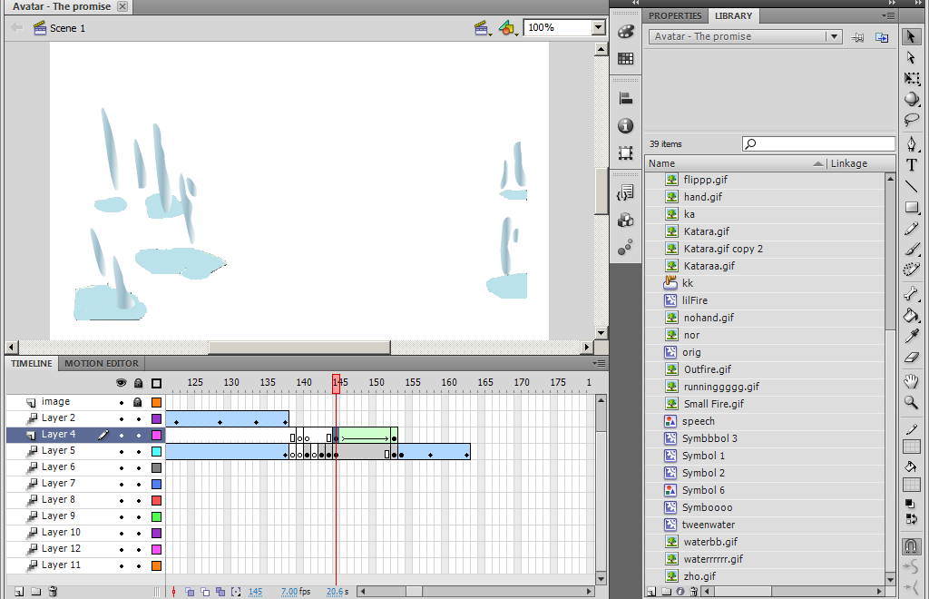
In flash I have mostly used motion tween, but in this case I have used shape tween (in the image above) so that I can be able to animate shapes that I have created in ways that I would like. In the image above I have used the shape tool in order to animate the water droplets to move upwards, and out of the puddles.
- Importing files
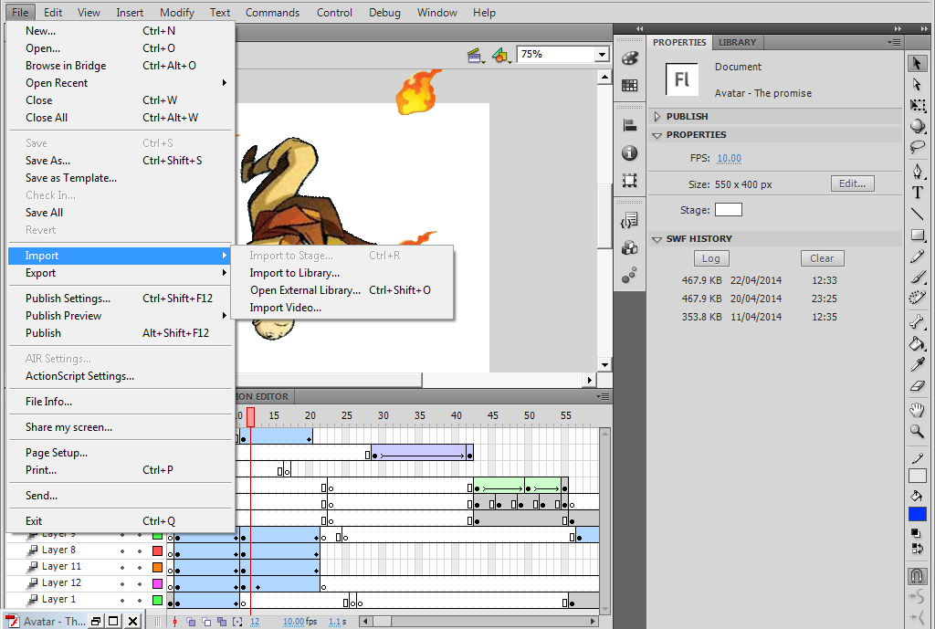
In order to import files you are to click on “file” and scroll down to “input” and it will open up a few more selections, and you can either choose from importing it to the library, to open the external library, or to import a video. In my animation I have used this tool in order to import all images into my animation and to be stored in the library.

- Testing your file
When testing your file you can simply test it by clicking the Enter button, or by testing it in the SWF file by clicking “CTRL + Enter” to open it up and play your animation. Being able to open it up in the SWF file means that you can test it with the benefit of viewing your animation professionally.
- Using Movie clips
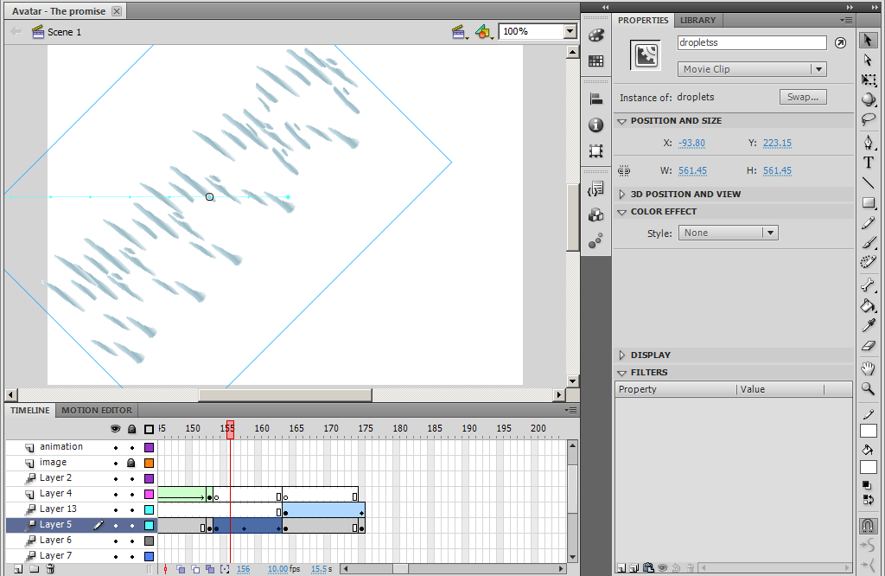
You can use movie clips in an animation to use them in motion tweens. In the picture above, the “droptletss” which is being animated on layer 5 can only be a tween if it is a movie clip (as stated in the properties).
- Using Frame by frame animation
In my animation I have used frame by frame animation for my character’s eyes to make them go from big to small (they were created by the shape tool and are highlighted in the image above). In the frames highlighted, these are the frames in which frame by frame animation takes place, and once played the eyes flash in a way that they are going from big to small.
- Organising the library
The way in which I organised my library which contains all the items used in my animation is by naming most of them so that I can be able to identify them. In this case I have named the graphic in the image above “Aang”, and whenever I need to use this graphic again I can simply click on the library and select this graphic.

