Evaluate visual style and elements of gameplay
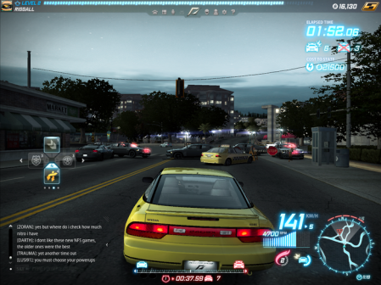
Concentrating on the visual style of a world, when playing a game it can be set in a terrain (landscape and natural features), architecture (buildings), or object (tables and chairs) world. The game opposite is set in an architecture world, featuring buildings and other cars. Good things about this game is that as it is set in an architecture world, it could be appealing to game players as it makes them feel like they are playing in reality, as it is seen as if it is realistic. Another thing is that the game is set in a three-dimensional world, giving players a 3D perspective of the game. Improvements to the game could be that maybe game players wouldn’t want to play a car game set in the real world. Maybe they’d like to set it in a terrain world with natural features that include soil and rocks. Another improvement which is to do with the perspectives of the game, as I have just stated that it could be set in a terrain world with landscape and natural features, the game can also be two-dimensional which can be played on computers and laptops, having levels after levels featuring in the gameplay.
Focusing on the gameplay of this game, the interaction model that allows the player to interact with the game is a car which allows the player to steer the car and drive it well in a realistic manner. Also the game previews feedback for the player to see their elapsed time, how many KMH they are going and what level they’re on. Improvements on the game could be that maybe the player would like a simple two-dimensional game where they can play the game on a computer/laptop or mobile device simply with a keyboard. The game does not feature characters whilst driving the cars, as the only thing the player can do is simply drive the car. It also has a lot of non playable characters whilst racing and so an improvement could be that the player would want only playable character to play with friends (making the game a multiplayer game), or simply just one non playable character to race with.
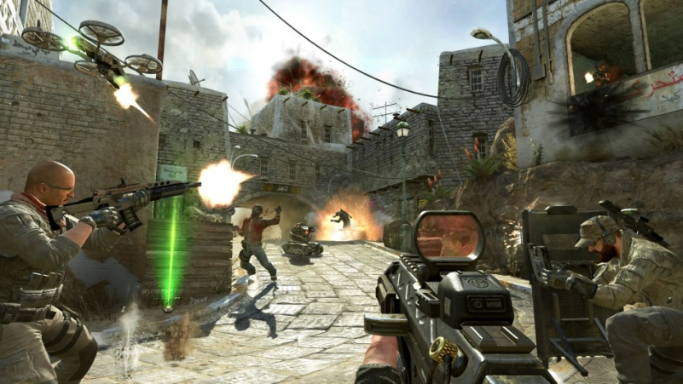
In the game opposite is the game Call of Duty: Black Ops. It is set in an architecture world that features buildings and objects such as guns and plants with first person perspectives three-dimensional, and also featuring buildings and non-playable characters throughout. Although three-dimensional, the game is set to be realistic, with high quality gaming, and characters that as realistic as a natural human being. The way that these could be improved is that as it is a shooting game, it could be two-dimensional instead and could be set in a terrain world to support it as a 2D game.
Looking at the gameplay of the game, although the interaction model is in fact a character, as it is 1st person, only the characters’ weapon is in full view, and it allows the player to shoot, run and pick up items. The way that this game can be improved is that it could have the playable character actually seen for the player who is controlling it as they might want to see exactly how the character interacts with the game if the player wants to pick up items, and shoot, and also just to be seen like all of the other individual characters in the game. There also isn’t any feedback available for the player to know how well they are progressing in the game, this can be listed as an improvement, as the player would need feedback to see their lives and score. It is also a single player game, this may be a good thing as it allows independent players to play the game on their own, but a way to improve it is to have it be a multiplayer for example if a brother and sister wanted to play together in the story mode.
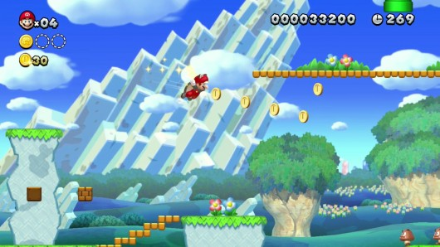
The visual style of this Mario game set in a terrain world, as it has landscapes and natural features such as plants and grass, it only had one character that is controlled by the player all throughout the game, and has many of other characters that are controlled by the game, with their aims to kill the Mario character. This game provides feedback available to the user to keep track of how well they are doing in the game, for example, their score is previewed at the top right corner, next to the amount of time elapsed in the game. IT also provides the user with feedback on how many coins have been collected and the number of lives they have. It also gives the player a 2D perspective of the game. Improvements to this can be that it could be set in an architecture world having the character complete missions in a world of buildings instead of having a landscape to view at all times. Also it should have more than one character instead of having the player continuously have to play with the same character over and over again.
Gameplay features of this game such as only having one goal of the game – to collect coins and make it to the end without dying could be improved. As this game is pretty simple to play, its main goal is for addiction to occur. A way to improve addiction is that the game should offer the player some challenges in the story mode, which can gain extra points for the player.

