Test Plan
Test | Purpose | Test Data | Expected outcome | Actual Outcome
Passenger Details | The purpose of the passenger details table is to display all the information within the fields of the table | Passenger ID, Title, First Name, Surname, Gender, DOB, Address, Town and Post code. | Every piece of information should be showing as the table is being viewed
Relationships | To be able to have relationships linked with other tables | Passenger ID | The relationships created will work when viewed in datasheet view, also for the primary keys to be linked into a foreign key
Query 1 | To create a query using the passenger details and only having the first name and surname, along with the gender post code, date of payment, price and flight ID being selected to be shown in the table | Gender & Town | Instead of having all fields in the table show, the ones selected whilst creating the query are to display
Query 2 | To have the query show only customers’ details living in the town of London appear on the table | Terminal & Class | All customers’ details that live in London are shown on the table | 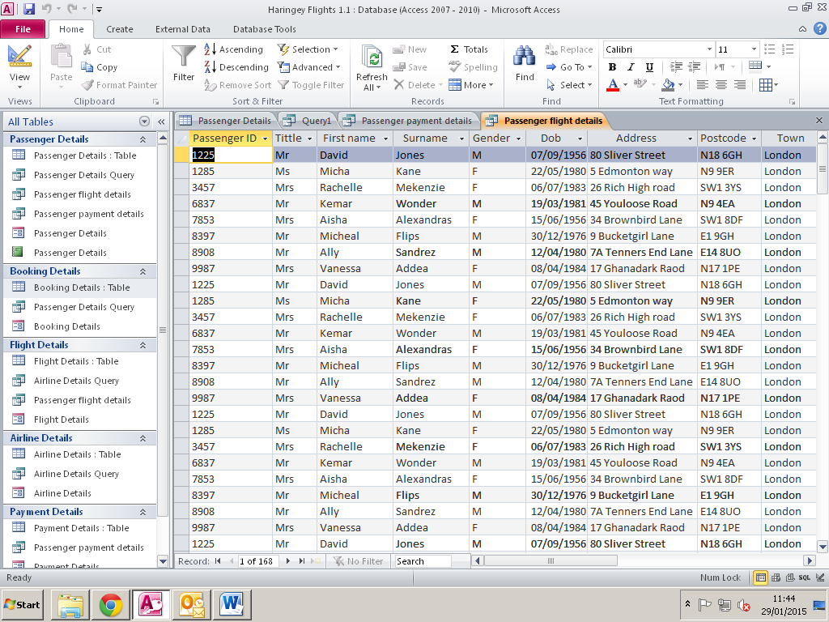  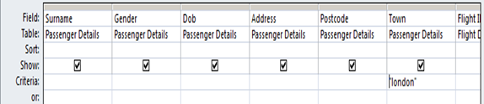
Input Mask | With the input mask the format has been set for 00/00/0000 (dd/mm/yyyy) to display the DOB of customers. Also once being typed in it should only accept that format. | Date Of Birth & Date | Once on the datasheet view all DOB are written out in the 00/00/0000 format.
Drop Down List | To have details preview in a list instead of having it typed in | Gender | Once clicked the option to choose M or F for gender will appear in a drop down list

