What was tested | How was it tested | Description
Software application open and work | I clicked onto the Microsoft word icon twice and it opened up | I double clicked on MS word for it to open and it opened up the file
Desktop shortcuts go to the right place | When creating shortcuts for Word, Publisher and Outlook they all successfully created a shortcut onto the desktop, and if you are to click it, it should open | 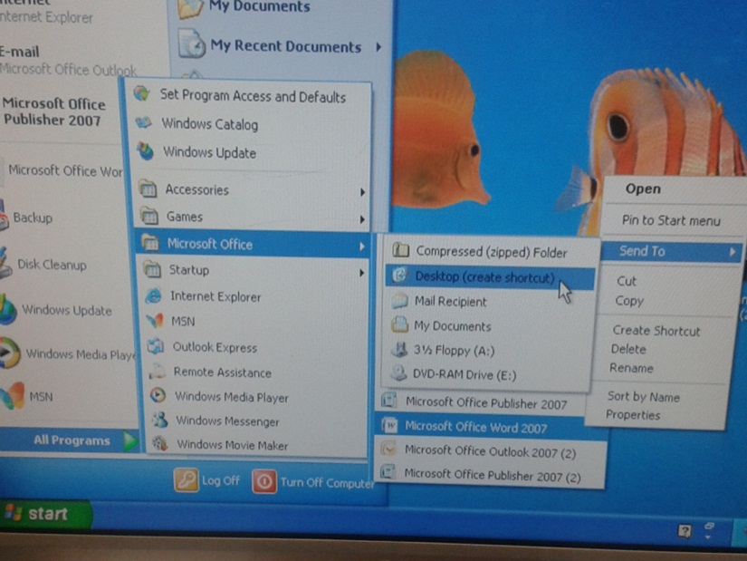  In order for me to create the shortcuts I was to right click on (for example) Microsoft word then select the option “Sent to desktop” and after doing so it created a shortcut onto the desktop
Correct date and time are set | After being able to alter with the time and date, I managed to change it back to the correct time | I clicked on the bottom right corner which displays the time and date, then followed on to click “change time and date settings” after doing so I was able to change the time and date
Default folder on MS word is working | Now when I click on Ctrl+S it directs me to the “ICT” folder in my documents | By clicking on the “options” setting in Microsoft word, I clicked on “Save” and was able to change where I could have my files being saved to. I selected my “ICT” folder, and now when I hit the “Save As” button it directs me to that folder  