P6 –

The software that I am going to upgrade is called ITunes. As soon as I open the software, before I can do anything on it (like listen to music), it already opens up a dial box to upgrade the software.

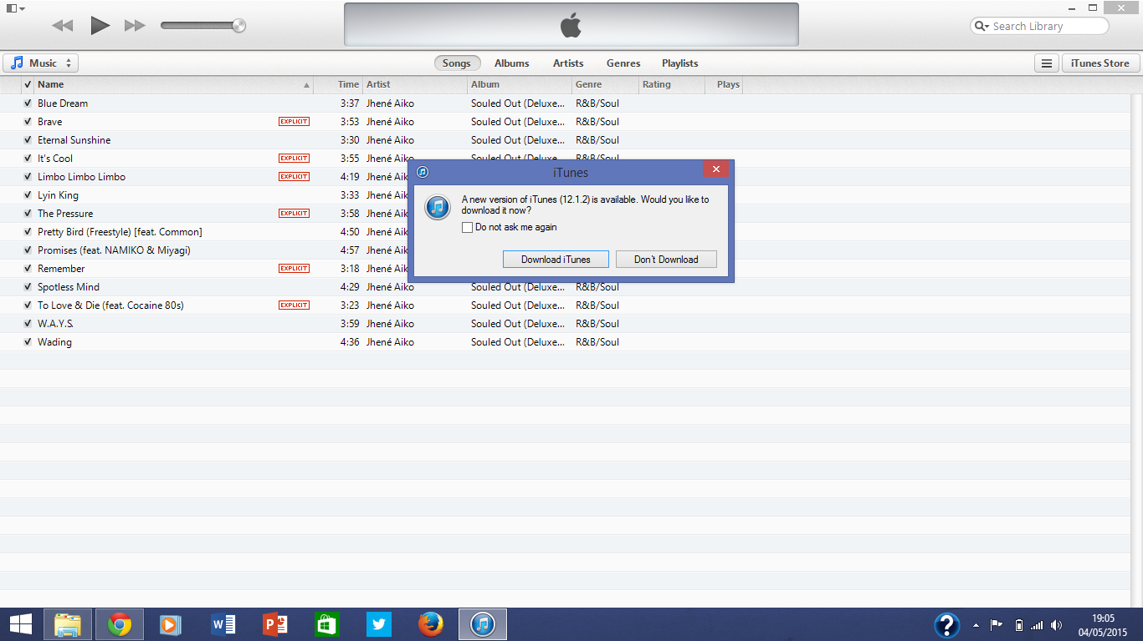

In order to begin the upgrading process I am to click the “download iTunes” button to begin.

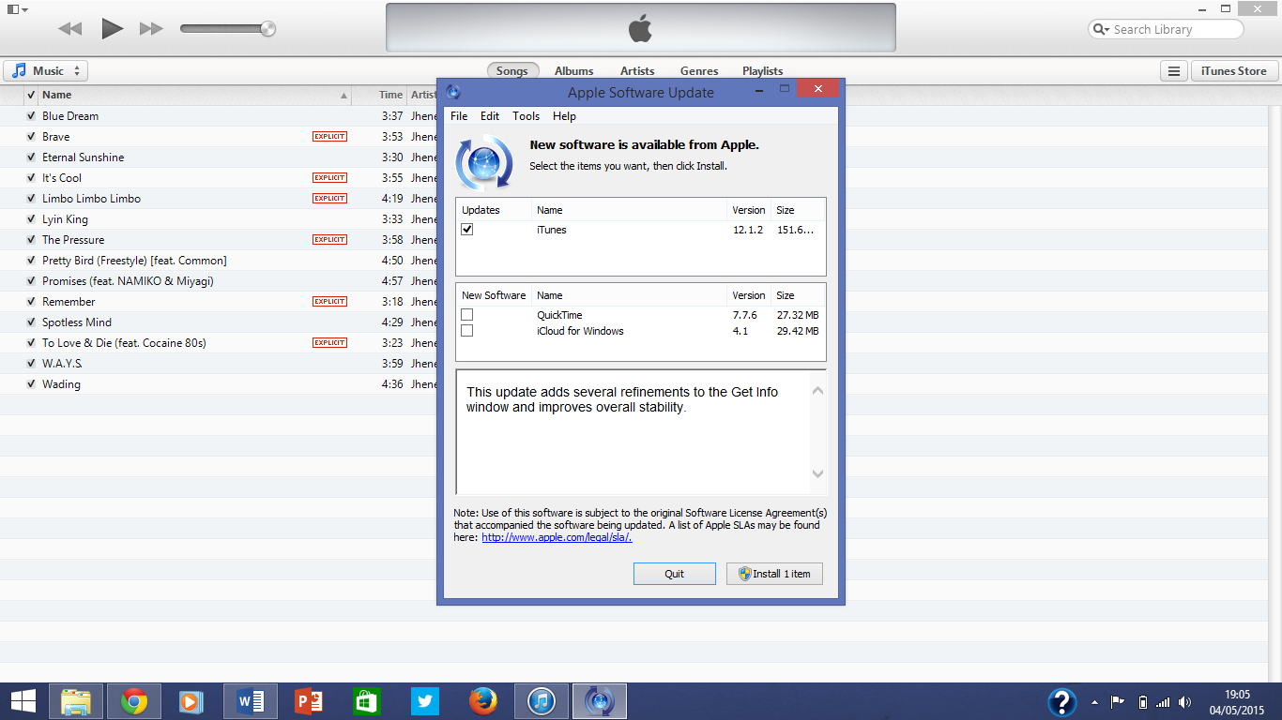

Before the installation starts, it asks me if I not only want to upgrade iTunes, but install other features that may be useful, as I do not, I only check the “iTunes” box, then click “Install 1 item” button and then the installation process will start to commence.

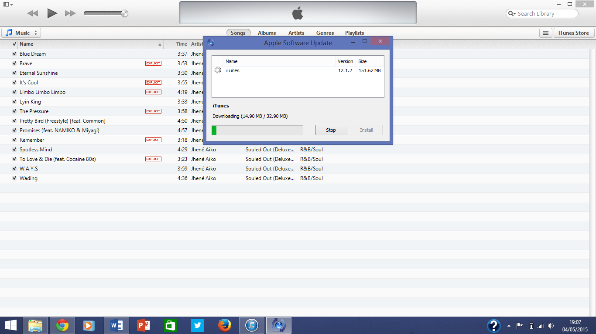

Here the upgrade is starting

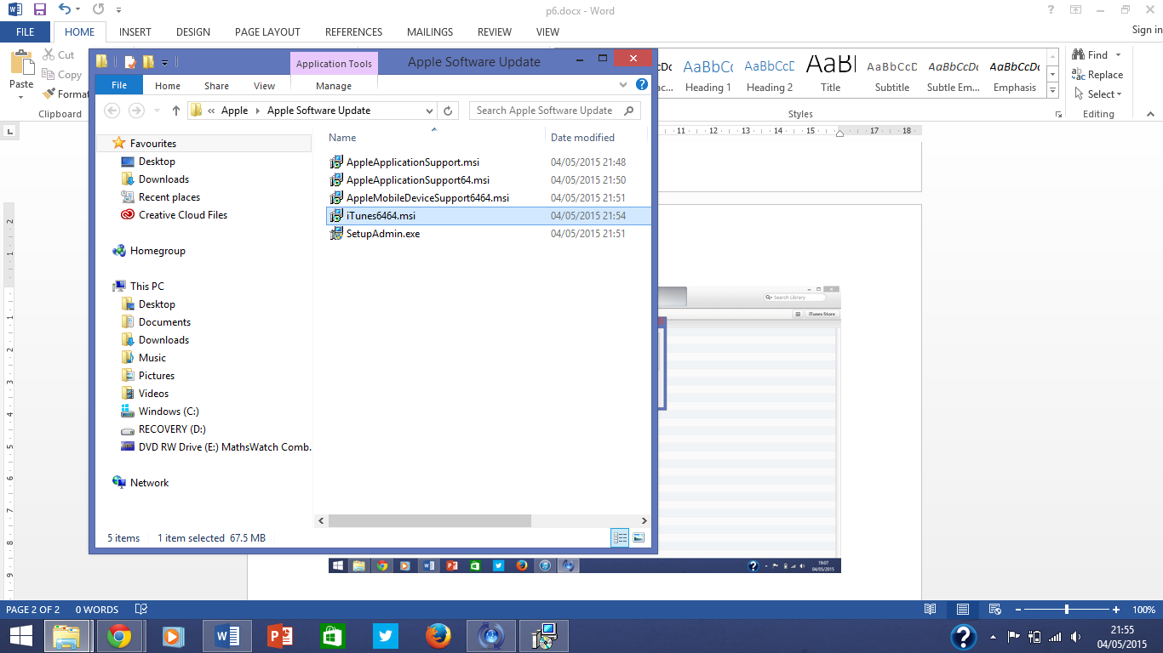

After that quick process is finished, this box opens up and I have to select which I need to install, in this case it is just iTunes that I would like to upgrade, therefore I click on the one I want and move on to actually upgrading the software.

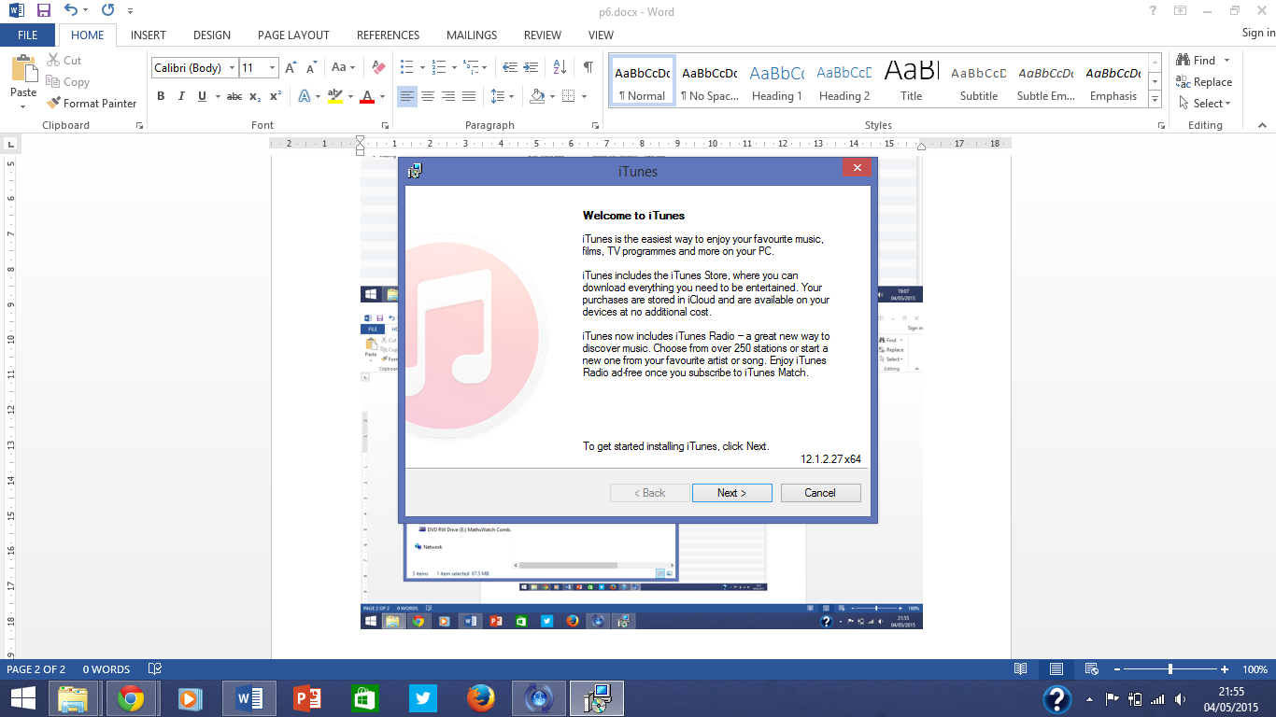

Finally the installation wizard appears, and I have to click next to officially start the upgrade process.

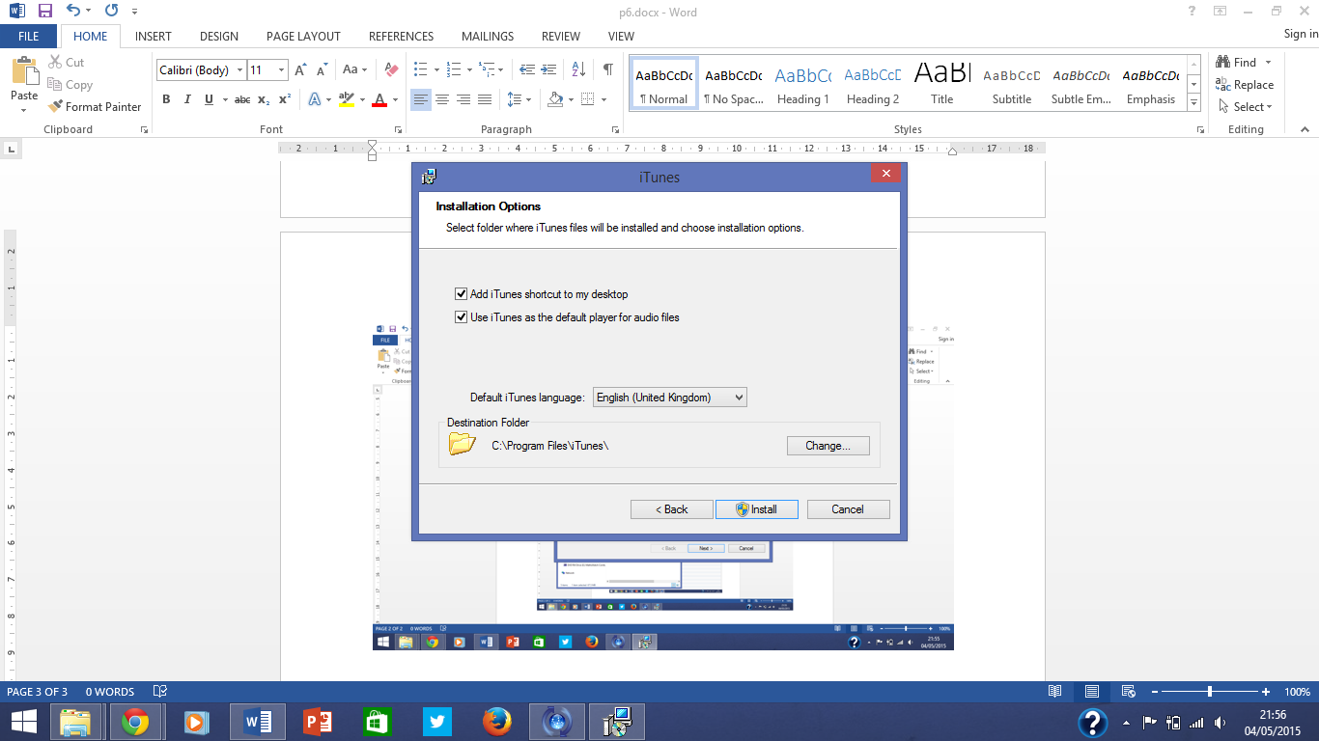

Here it is giving me the option to add iTunes to my desktop as a shortcut and to use it as the default player for when I play music on my computer system, and also asking for the destination folder (which I have left the same), I have ticked both boxes and have now clicked install.

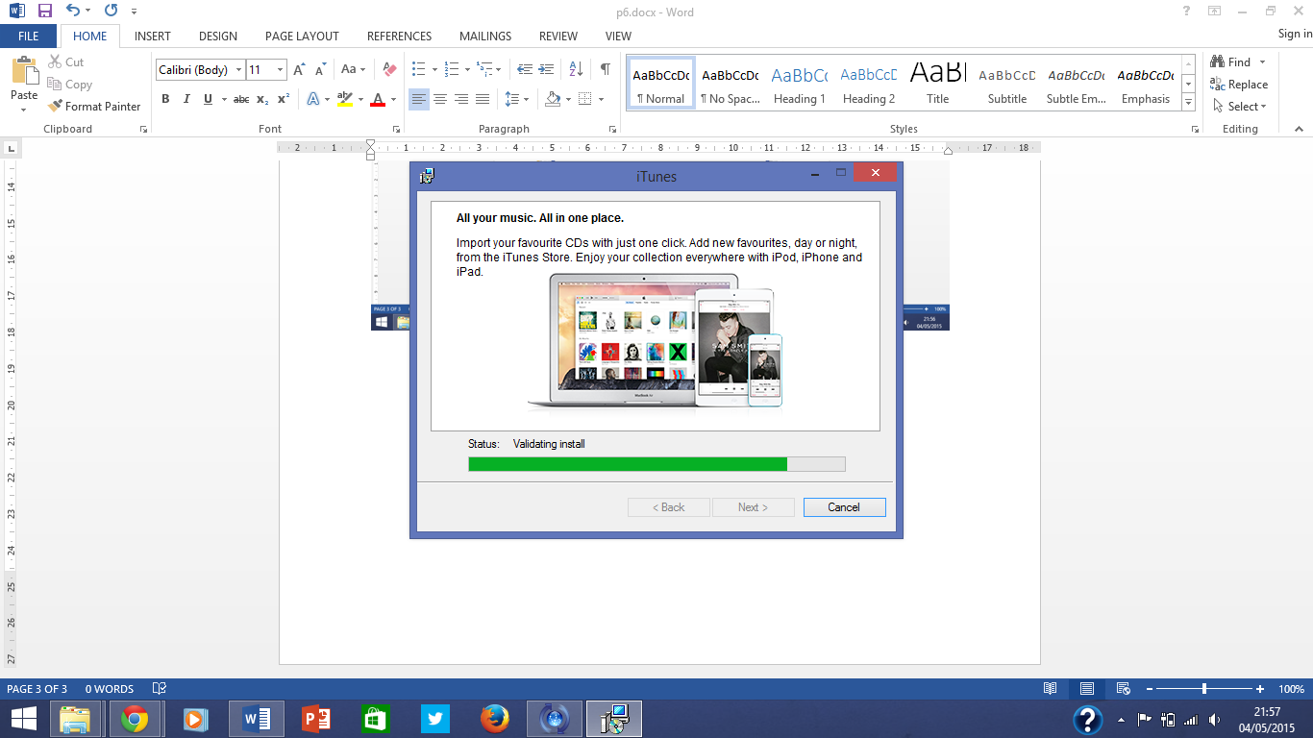

Finally the process has begun and is not installing the updates.

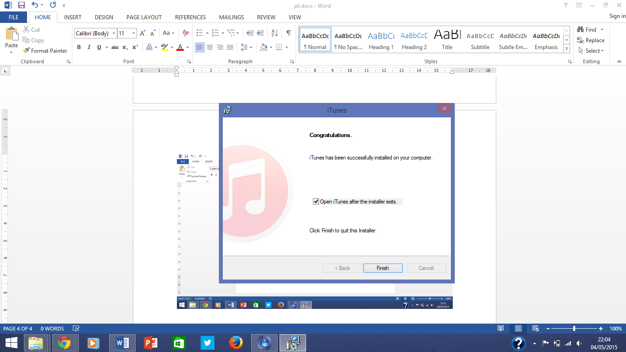

The upgrade has now finished and I can now open up the upgraded version of iTunes.

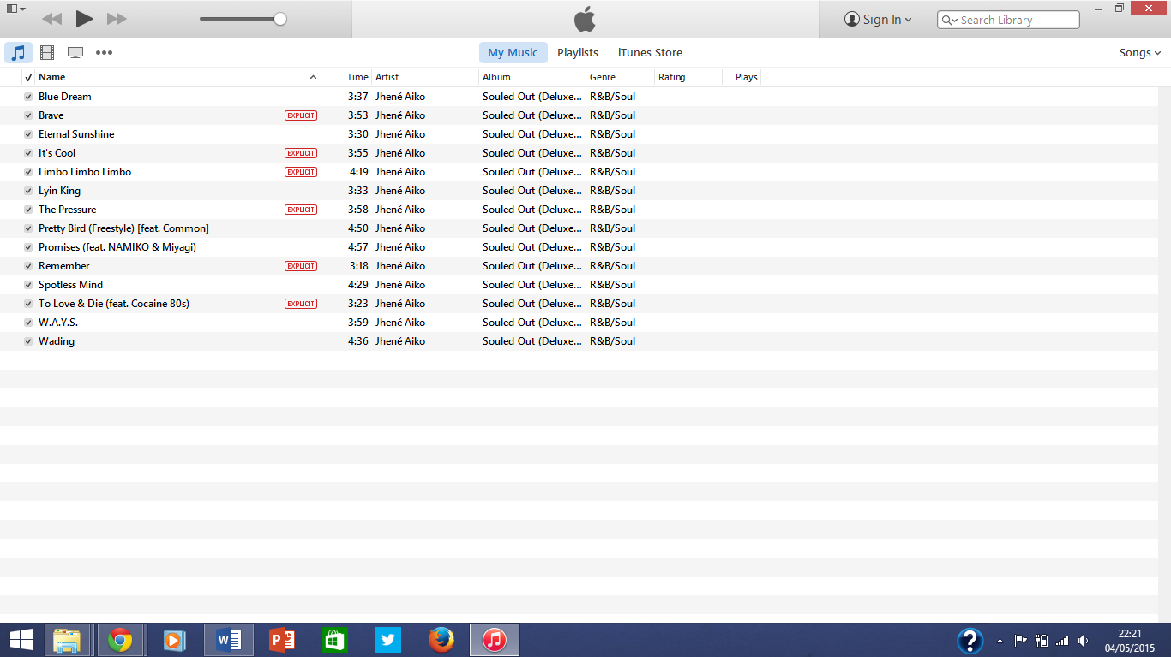

Now when I view the songs in iTunes, everything has now changed, for example it has a new design.

