Number of Frames Used: 6 1  Length of time in Seconds: 0.7 | Number of Frames Used: 6 2  Length of time in Seconds: 0.7 | Number of Frames Used: 15 3  Length of time in Seconds: 4
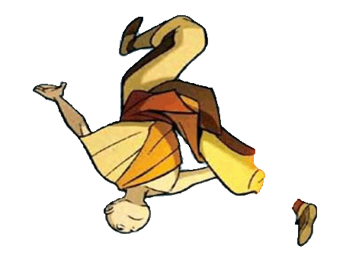 | 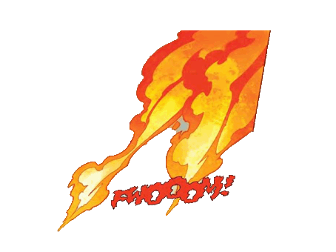 | 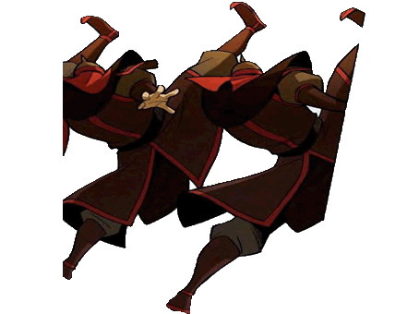
Description of animation:  The boy is in the air and is almost getting hit with fire, and he is flipping over trying to avoid it | Description of animation:  As this is the fire that is going to hit the boy whilst he is in the air, I will animate the fire as if it were to be burning him | Description of animation:  These are the people causing the fire so I will make them zoom in a bit making them a bit larger
Number of Frames Used: 16 4  Length of time in Seconds: 2 | Number of Frames Used: 6 5  Length of time in Seconds: 1 | Number of Frames Used: 16 6  Length of time in Seconds: 2
 | 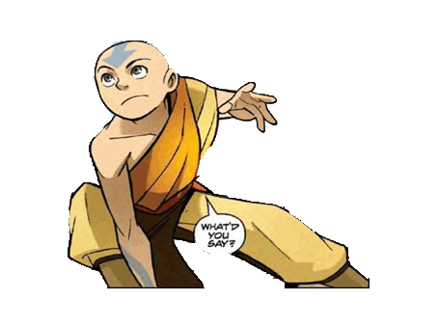
Description of animation:  In the frame that this girl is in, I will enlarge her making her zoom in and add a speech bubble making her say “Aang you’re on fire” because she is alerting the boy. | Description of animation:  With this character I am going to keep him still and leave him exactly how he is | Description of animation:  As this piece of fire is originally attached to the boy on the left, I will animate this piece of fire and make it burn
Number of Frames Used: 15 7  Length of time in Seconds: 2 | Number of Frames Used: 26 8  Length of time in Seconds: 3 | Number of Frames Used: 12 3  Length of time in Seconds: 2
 |  | 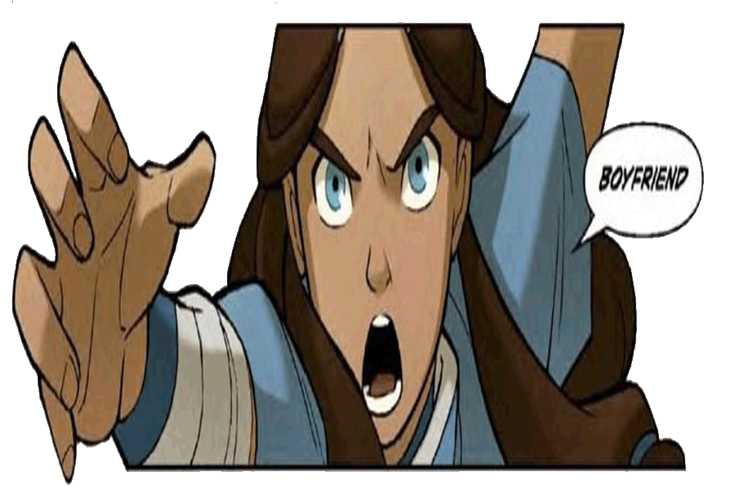
Description of animation:  The water will be animated in order to take out the fire on the boy | Description of animation:  The water will be animated | Description of animation:  The girl will just grow larger (zooming in)
Number of Frames Used: 18 10  Length of time in Seconds: 3 | Number of Frames Used: 12 11  Length of time in Seconds: 2 | Number of Frames Used: 12 12  Length of time in Seconds: 2
 | 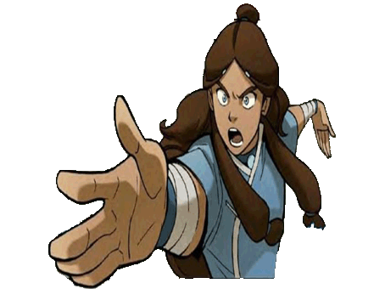 | 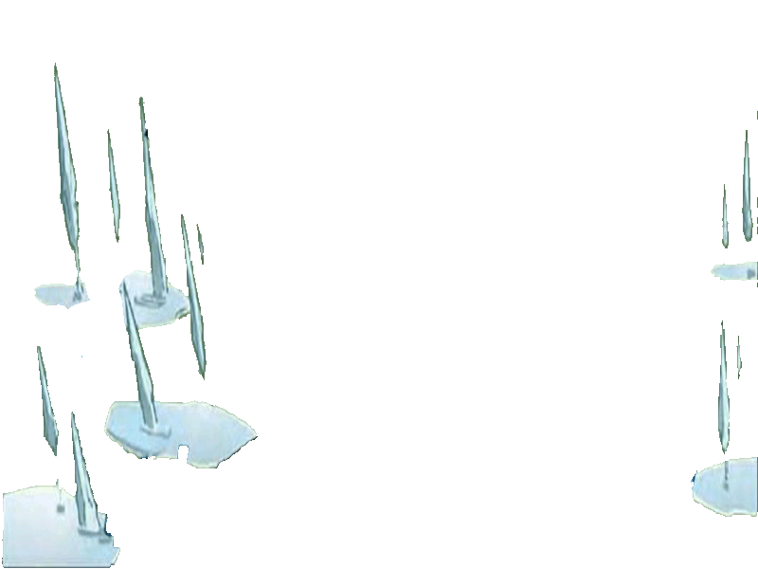
Description of animation:  In this little cut scene it will just pan through (from right to left) just to show the success of defeating the fire nation | Description of animation:  When it shows this character here, as she is angry she will just zoom in and get larger (there will also be a speech bubble of her shouting some words) | Description of animation:  All the crystallised water will rise when animated

