Maths space
User Manual

Introduction
A space themed maths game, created to give kids over 11 a fun and educational game to practise their times tables (and hopefully remember them!).
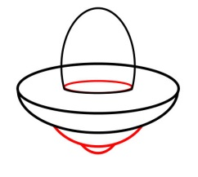
9x8
84
72
58

91

System requirements
- General PC (No Macs as it does not support flash)
- Enough RAM space
- CPU
- Hard drive
- Flash player
- Graphics card
Installation
- Requires Adobe Flash Player in order to run SWF file.
- Doesn’t require much memory to download
On the website www.itsMathsSpace.weebly.com, under the online game you are able to download the SWF file below.

To download the game you are to right-click where it says “Download File” the click “save link as”.

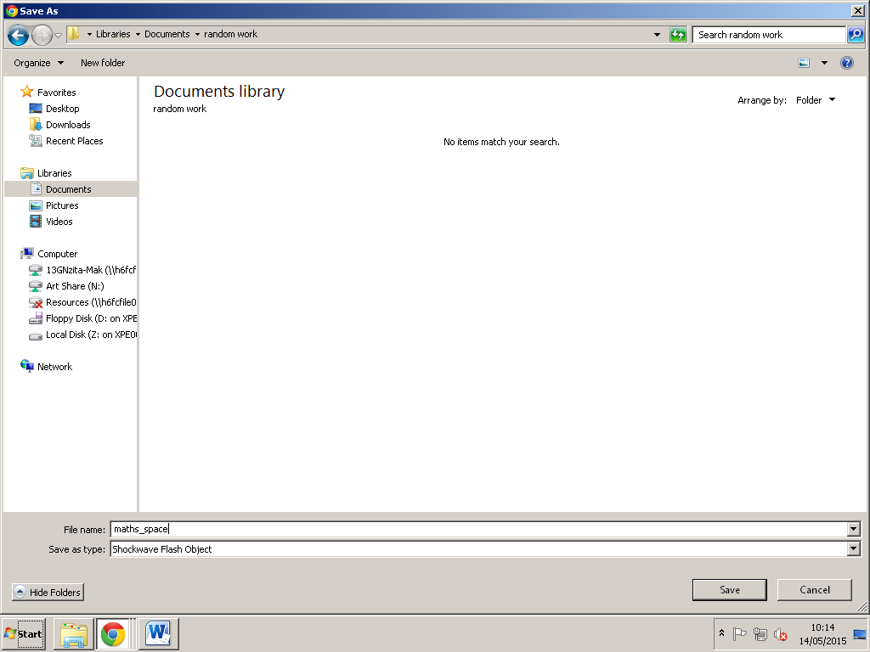
As you have clicked to save the file you will then be directed to your folders and you should select where you wish to save it then click “save”.

After clicking save your download should show on the downloads bar ready for you to click and open it to play the game.

Play
Up arrow key:
Moves ship right
Up arrow key:
Moves ship upwards
Right arrow key:
Moves ship right
Up arrow key:
Moves ship left
Down arrow key:
Moves ship down
Left arrow key:
Moves ship left

The aim of the game is to score as much right answers and as much points possible. Therefore, to score high amounts of points players must shoot at the correct answers, which will then give them +50 points. If they shoot at a wrong answer their points will decrease by 10 points.
In order to play, the player can either play the game online or download game, save it to a folder and open it up in the SWF file (which requires Adobe Flash Player) to play the game.

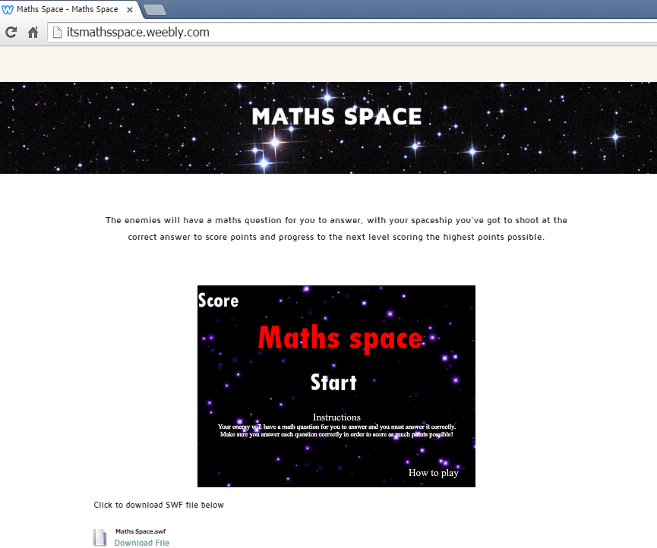
In order to play the game, players must go to www.itsMathsSpace.weebly.com and must have flash player to run and play the game.
If you have flash player then you are able to play the game online.

Trouble shoot
- If you can’t load up the game, what you should do is refresh your browser and see if it works after you have done so
- If it still cannot be played on your web browser, switch to a different one (Chrome, Opera Firefox etc..)
- Another issue could be that you do not have a current version of flash player that supports the SWF file, therefore you should reinstall Adobe Flash Player to run the file
- If you have done all of the above, reinstall the game and it should be working. If it doesn’t then you must be using an Apple Mac, which doesn’t support Flash player

Help
If you have any further issues, contact me via email on:
GladysNzita@hotmail.co.uk
Credits
Author, the creator of Maths Space: Gladys Nzita-Mak

