Create an interactive website to meet a client needs
The first thing I did to create a website was to obviously register, then I was directed to this page to pick whether the website I want to create is a site, blog, or store. The option that I obviously chose is to click “site”.

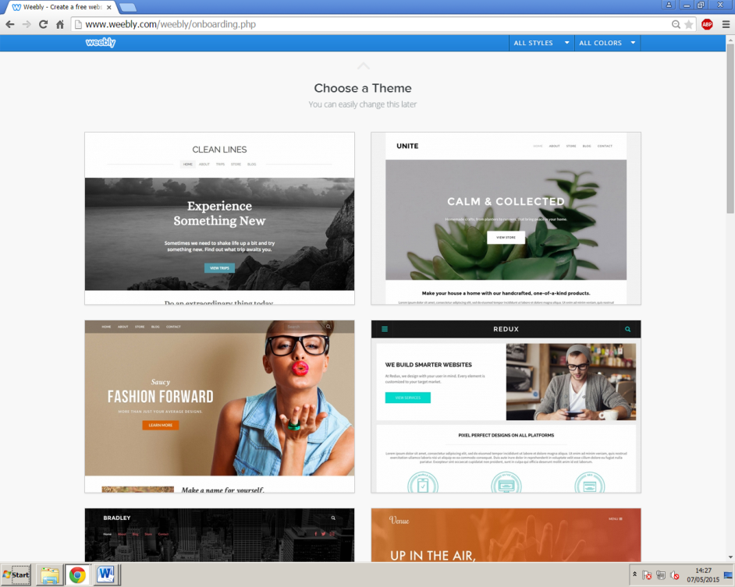
I am then asked to choose which theme I would like to choose for my site, and the theme that I have chosen is the one highlighted in the image on the left. This will be the template that I have chosen for the site I am going to be creating.

I then have to choose a subdomain that I would like to use for my site, and what I have chosen is simply my name.

I firstly started with the border of my homepage.
I am not going to use a headline, but instead going to use an image for the boarder, therefore I have to click “Edit image” in order to use one.
After clicking it I have to go on to click “upload a photo from your computer” then select one from browsing through my folders and open that image.

As I don’t wish to edit the image by making it larger, or making it brighter, I proceed by clicking “Save” then by making sure the image is set to only appear on the homepage I am adding to.
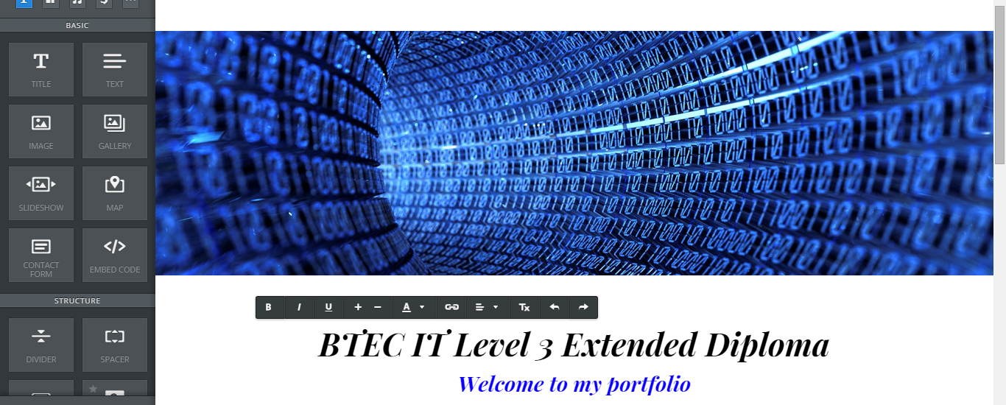
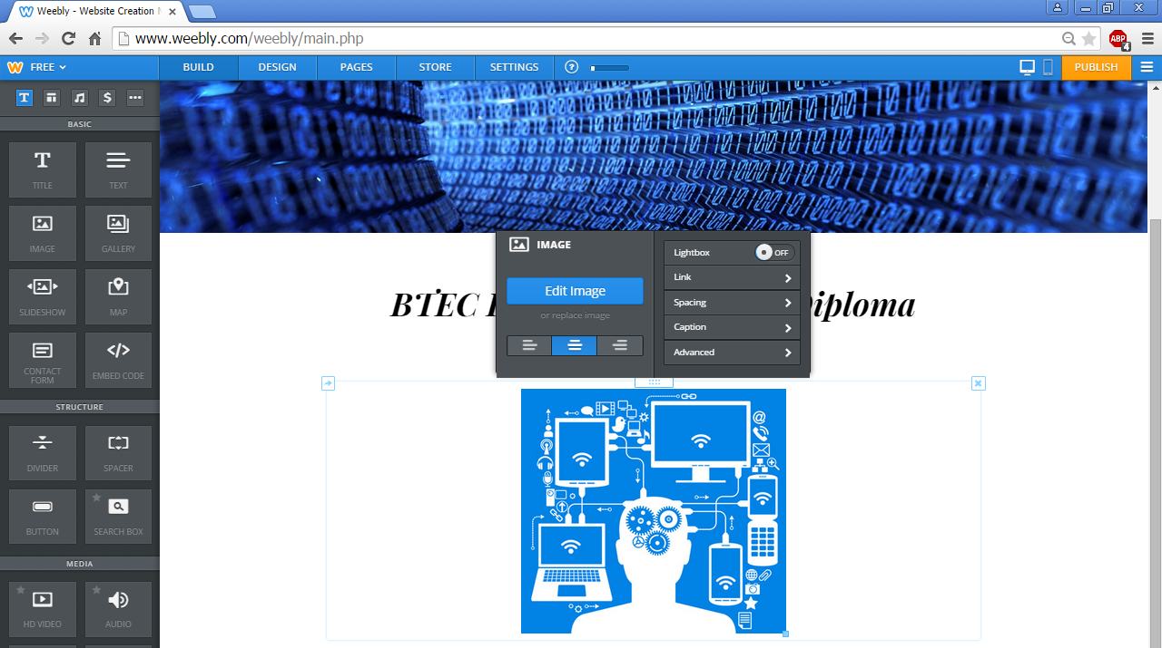
I then start adding text to my site. This can be done by clicking and dragging the text button (which is highlighted on the image above) onto the page to create a text box and start typing.
With the black bar on top of the text I am able to make text big or small, and even change the font colour as I have done above.
To add an image, you are to click and drag from the navigation pane onto the page, then browse for photos through your files. I have chosen to add this second image onto my homepage under the text I have previously added. I don’t feel the need to edit the image, so I shall leave it exactly how it is.

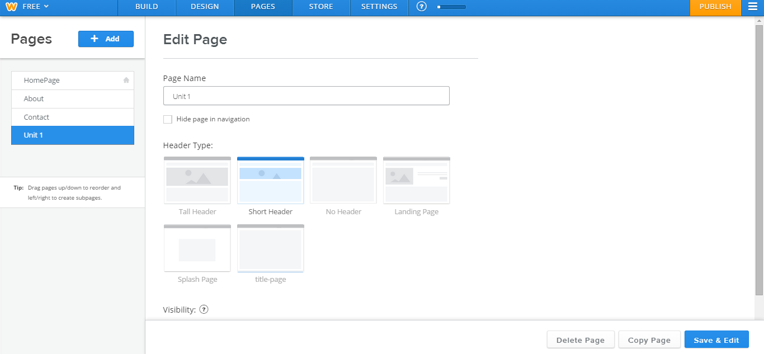
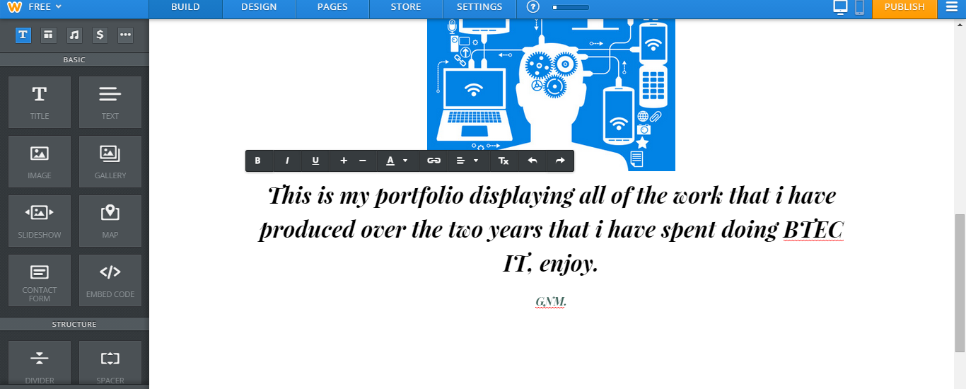
I have added some more text to the homepage, obviously by dragging the text ion to the page, and editing the text with the black bar with editing tools above it.
I have now started creating more pages in my portfolio. The first page that I have decided to make is the Unit 1 page. In order to do so, you click the “pages” tab at the top, click the “+add” button to select which type of page you want to add (which is a standard page), then edit the page name, choose your preferred header type and finally save and edit the page.
I have decided that I want to keep every other page in my portfolio with just a coloured header instead of having the same image as the header which is on the homepage. What I have already done is edited the header of the page naming it the title of the unit.
Now that I have created my page, I have began to start adding in all the documents related to the unit. What I have done is from the left navigation pane, I have clicked and dragged “file” onto the page, and it has now asked me to “click here to upload file”. Once it has been clicked, a browser appears for me to select which files I wish to upload. Once I have selected the file it will start to upload onto the page previewing this:

And once completed it will let you know and show your file on the page.
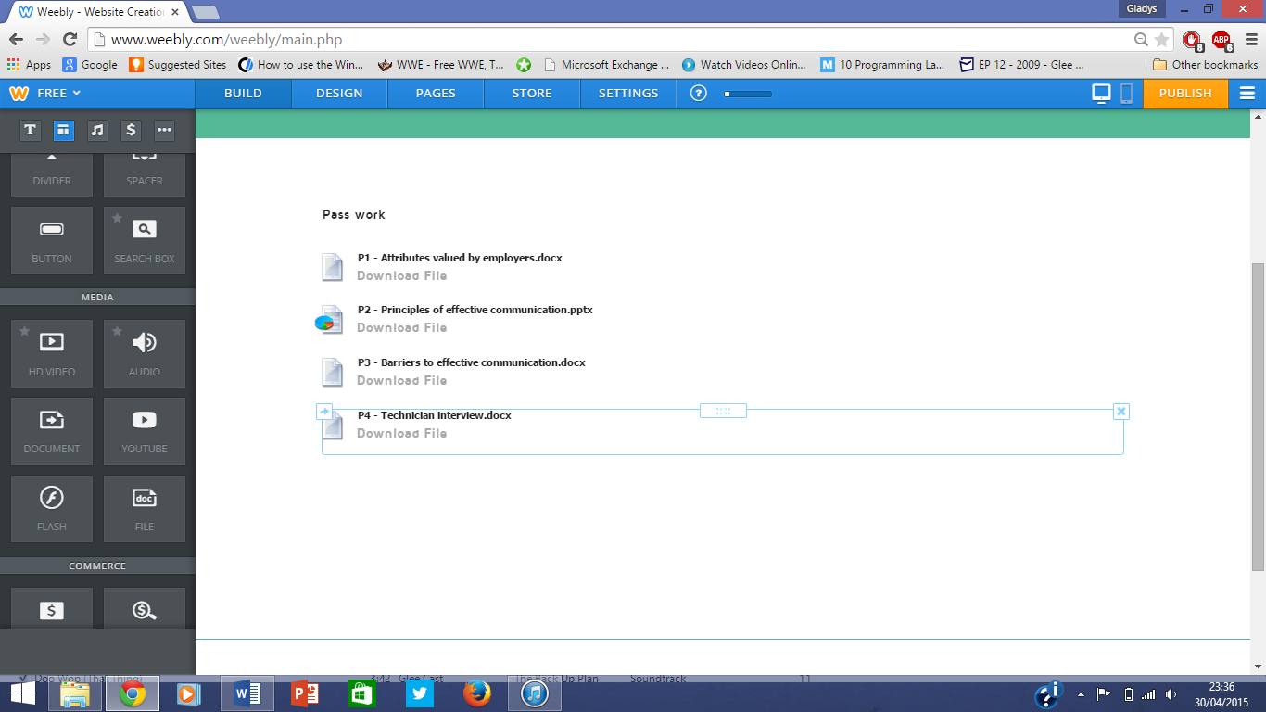
This is exactly what I will do for every other unit page in my portfolio.

The final page I have created is the contact page.
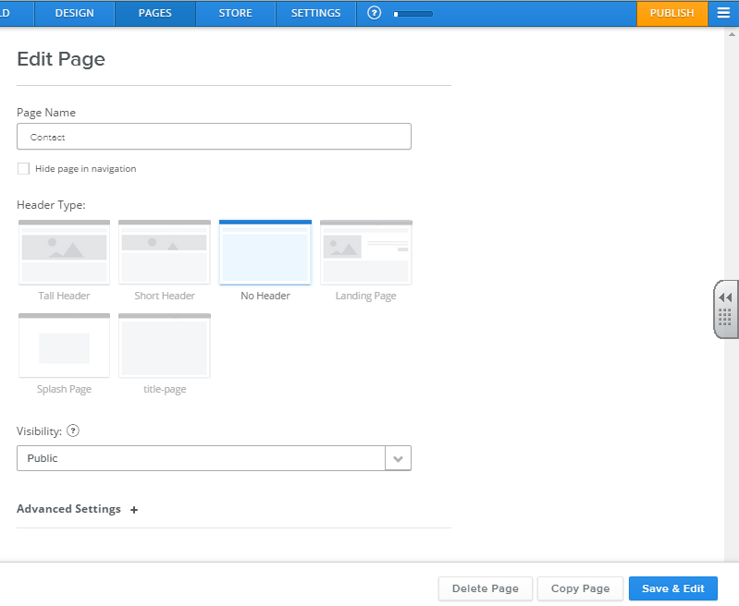
As this page will be short, it doesn’t need a header; therefore I selected the option to have no header.

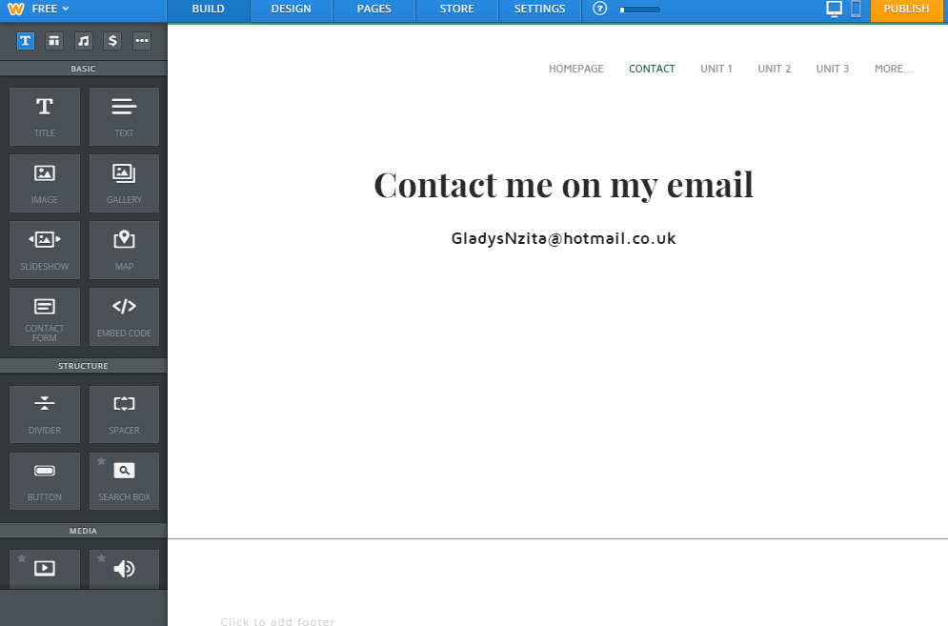
As mentioned above, this page doesn’t have a lot of information, and so the only things I have added is a title and text (highlighted above).

