P5 – Use monitoring tools to assess system performance
The first tool that I have used is disk defragmentation. Disk defragmentation makes sure that all files on the hard drive are all sorted out and are not scattered anywhere on the disk so that they are all easy to retrieve when needed to be opened.
In this screenshot it shows that all the hard drives in my computer system are 0% fragmented, which means that all files are defragged and sorted out, not be cluttered anywhere. The fact that I have the disk defragmentor schedualled weekly means that my computer systems’ performance will run smoothly and when it comes to running programs and accessing files, they will be retrieved as quick as possible, overall meaning that everything is running efficiently.
The second tool that I will be using is an Antivirus software called MacAfee. With McAfee I am able to run scans and check for updates that my computer system needs to carry out. In the image I am about to scan my PC to check if there are any viruses or other threats on it so that it can remove them and prevent these issues from happening again.
The scan I have chosen to carry out is the quick scan.
After clicking for the scan to commence, the scan starts to begin making progress.

Here is the scan almost completed, having gone through quite a lot of items on my computer system checking them all.
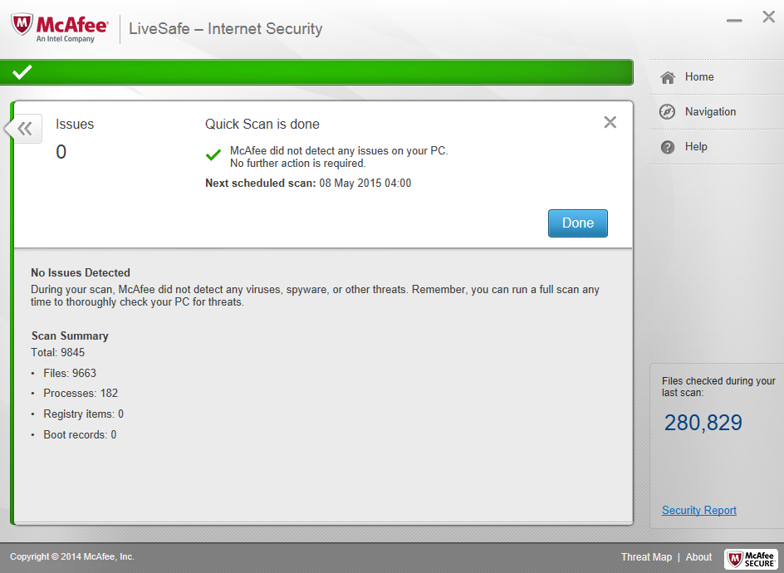
And once finished it shows me a complete overview of how many items have been scanned, and if any threats were found or removed during the scan.

Having an antivirus means that it can detect and identify them and can prevent them from doing and damage to the computer, as well as removing them, and that is why they are so important, if installed and updated frequently, antivirus will not only prevent viruses attacking a computer system, it will also improve the computer’s performance and have everything running fast as there won’t be any viruses hiding anywhere on the system. So for example, to keep a computers’ performance well from viruses, you can simply set scheduled updates for the antivirus to run scans either on a day to day basis, or weekly, and this secures a safe protected computer system.

