P3 – Describe a planning technique that can be used to schedule maintenance activities
Gantt chart
A method of planning out maintenance activities is by using a Gantt chart. Gantt charts are used to plan out projects that are needed to be completed, and used to check a tasks’ progression. In the image below is an example of a Gantt chart. Each task is tracked over the course of 7 days (a week). The chart uses horizontal bars to show exactly the progression of each task. In the left margin contains the tasks that are going to be tracked, and at the top are the dates in which it will be carried out. The purpose of using a Gantt chart is to give people a visual representation of how exactly their tasks look like in the process of being carried out, how long it will take and when the tasks will be finished by.
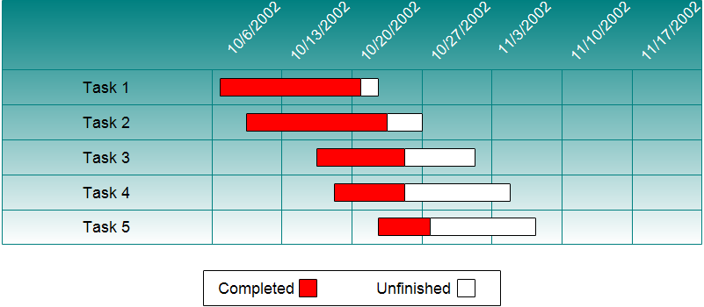
Gantt charts can be used to schedule maintenance activities by using it to planning ahead before performing the task. You are ensuring that by planning you will be tracking the time it will take to carry out the tasks, and when it will be finished. For example the Gantt chart can be used to plan out the process of how long a full backup will take in an organisation (backing up every single computer they have), and when it will be finished. By using the chart the organisation will be able to record the progression of the backup and over the time see a visualised picture of how the full backup has turned out.

