P3 - Create and populate a database

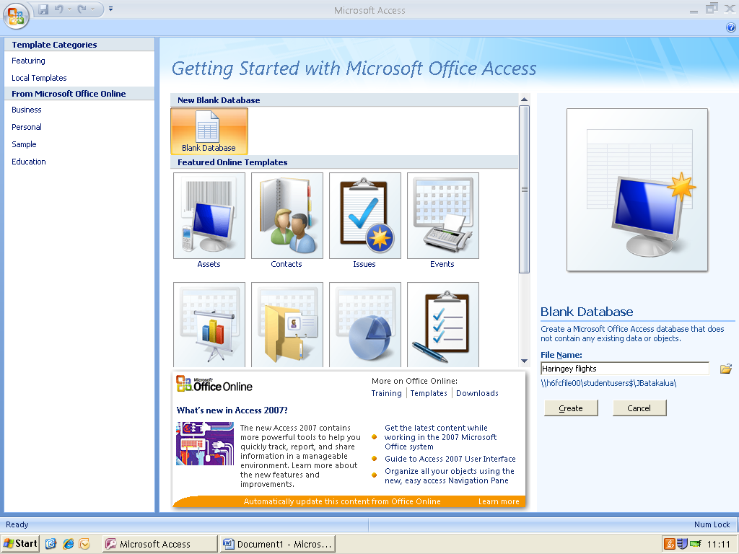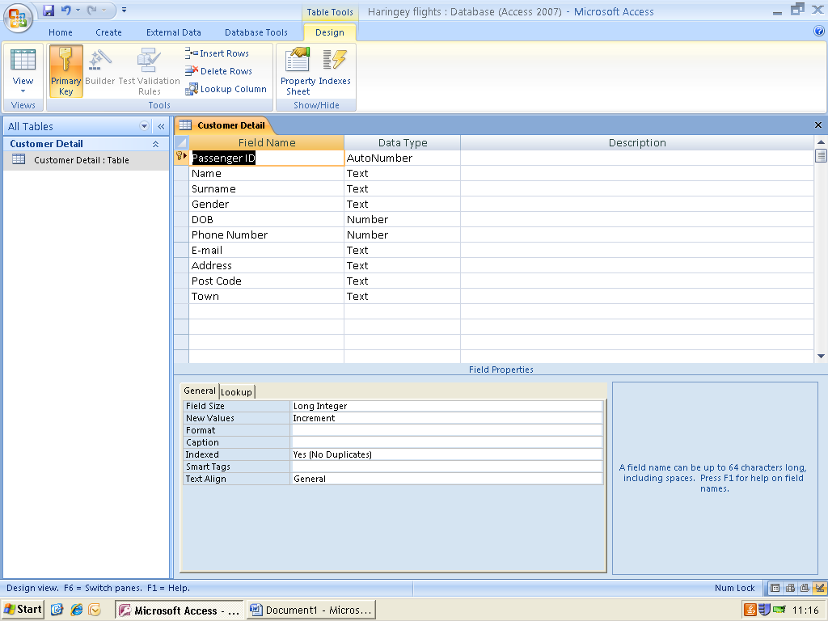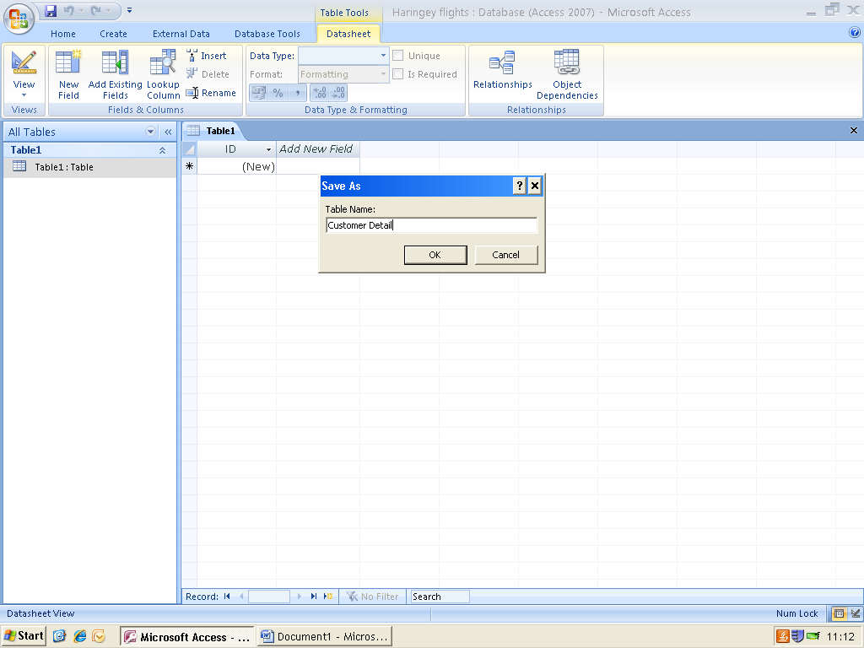

I have then started creating my table. I have firstly named the table as “Customer Details”.

Firstly, once opening Microsoft Access you are asked to name the file, and so I have named it Haringey flights

I have then begun to create the field names that the customer details are going to be filled with. It starts off with the primary key being named as the “passenger ID” to having an “address” field then finally the town in which the customer lives. Data types for each field have been selected, varying from text, number and auto number.

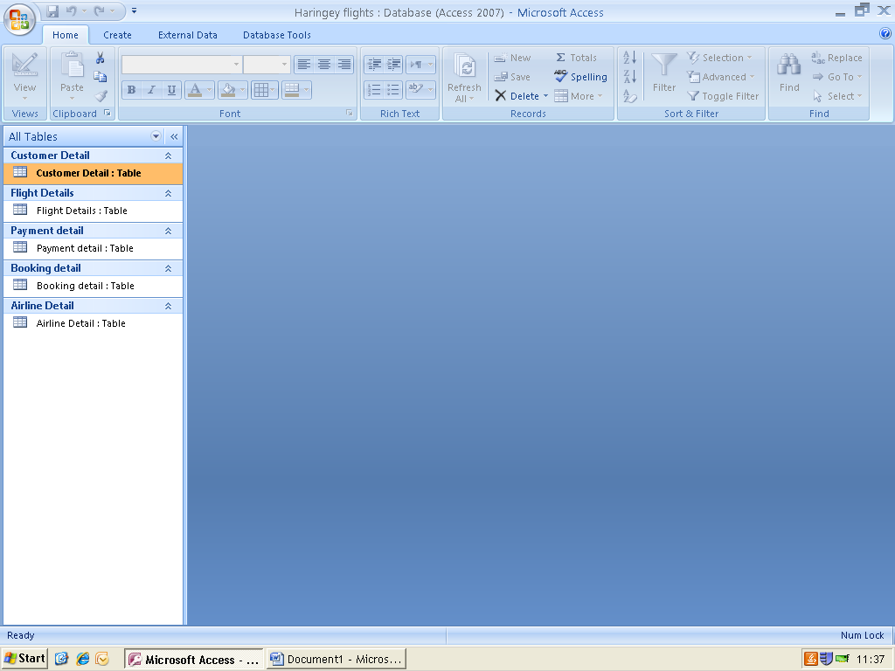

These are all the tables I have continued to add into the database:

* Customer details
* Flight details
* Payment details
* Booking details
* Airline details

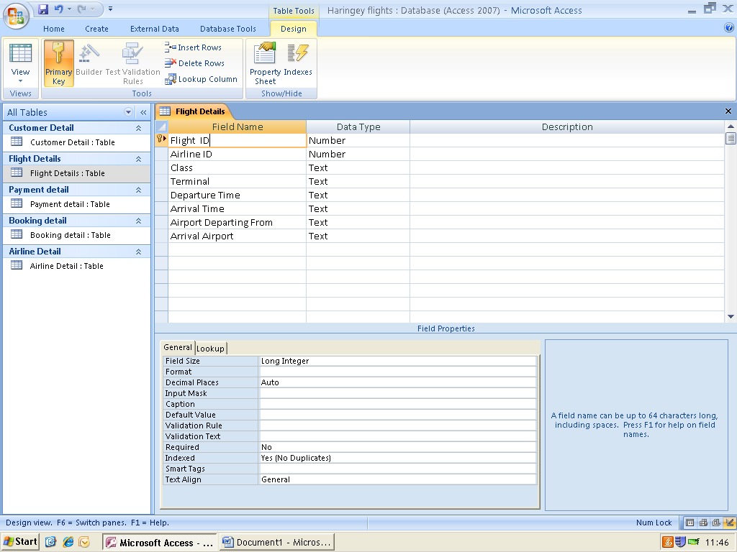

Here in the “Flight details” table I am adding in the names of the fields that I want to be included in the table and also the data types.

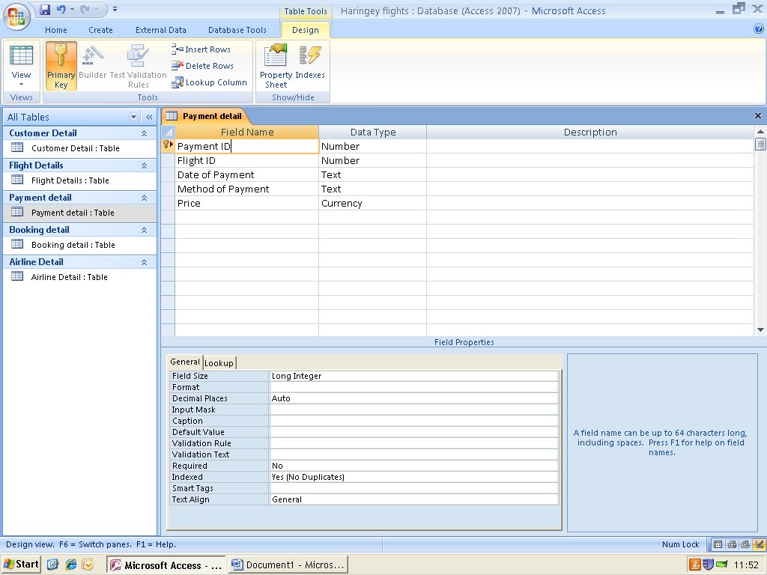

In the payment details table, the field names are being entered, and also have their data types selected

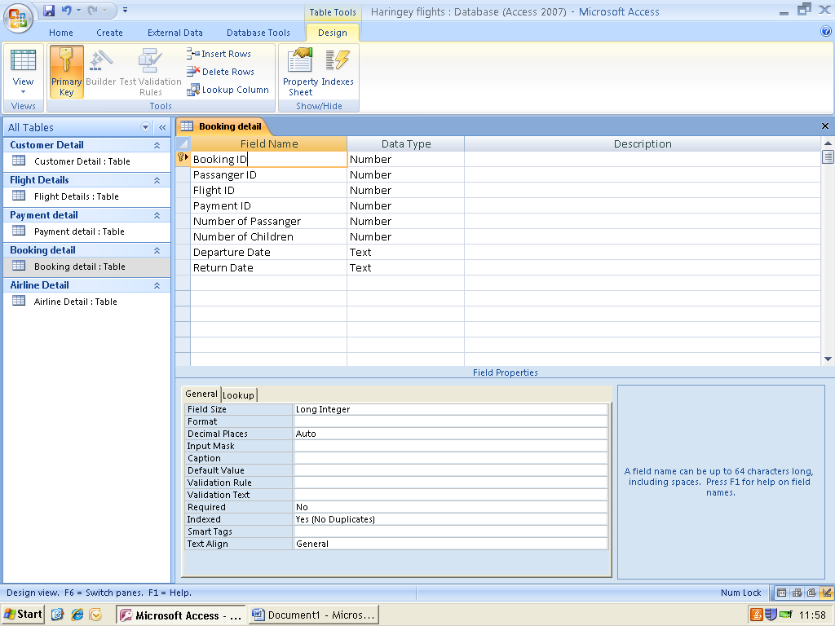

The field names and data types for the Booking details are being filled in

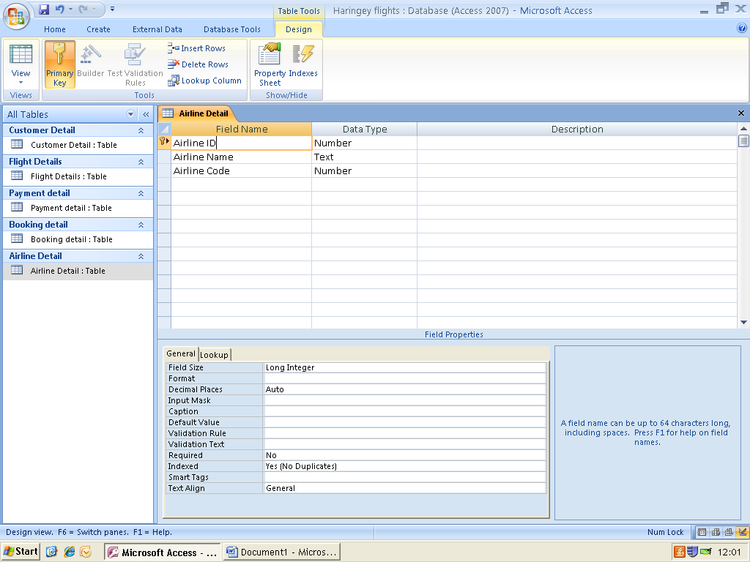

Field names and data types for the Airline details are being filled in

P4 - Create features in data entry form to ensure validity and integrity of data.

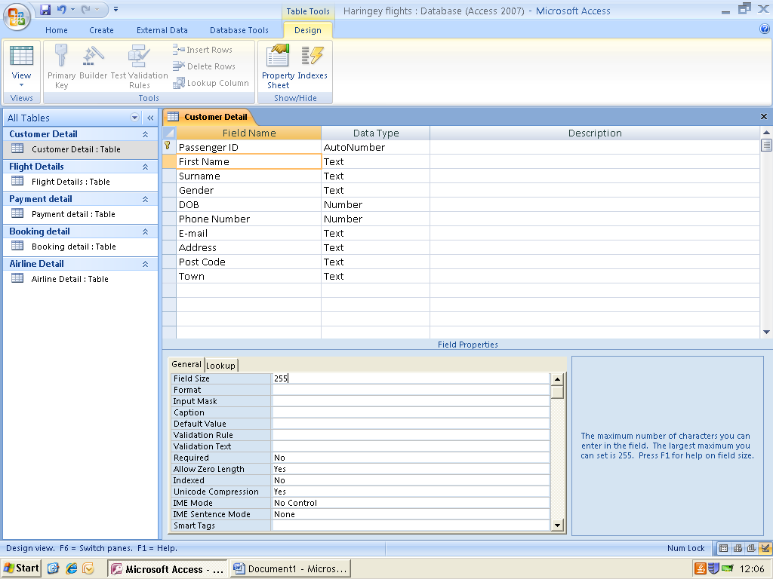**Field size**

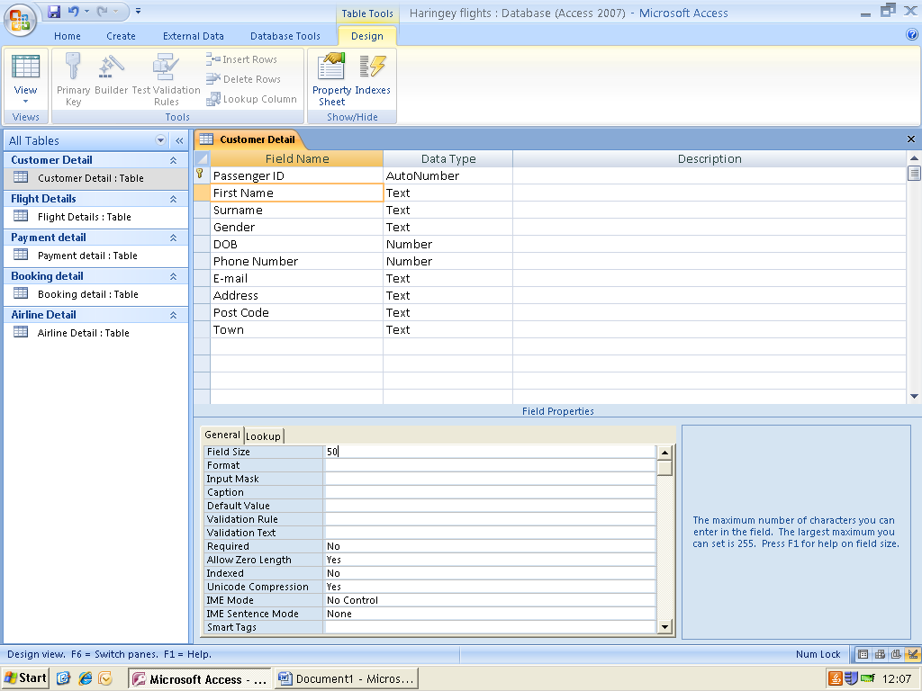

In this table, what is being done is the field “First Name” is having its field size’s number of characters changed from 255 to 50

**Combo Box**

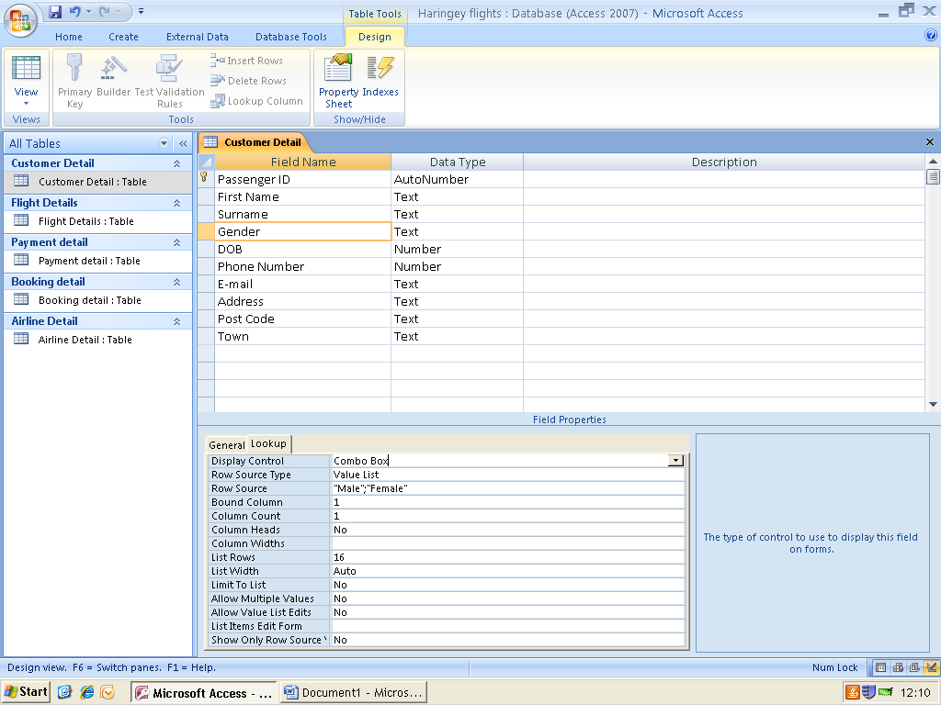

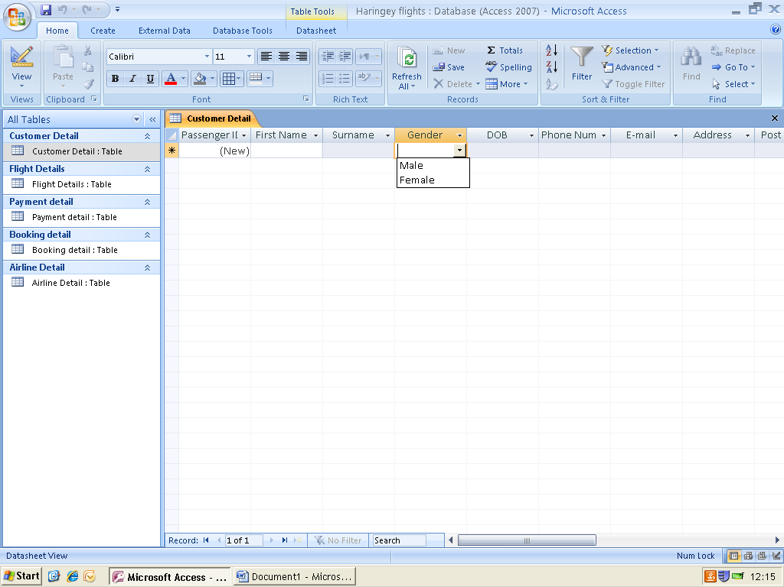

With the combo box, what is being done here is that the gender section is being made into a drop down list for customers to click and select their gender being male or female

And once viewing the table in datasheet view and clicking onto the gender field, a drop down list will appear for the customer to select which gender they were

**Input Mask**

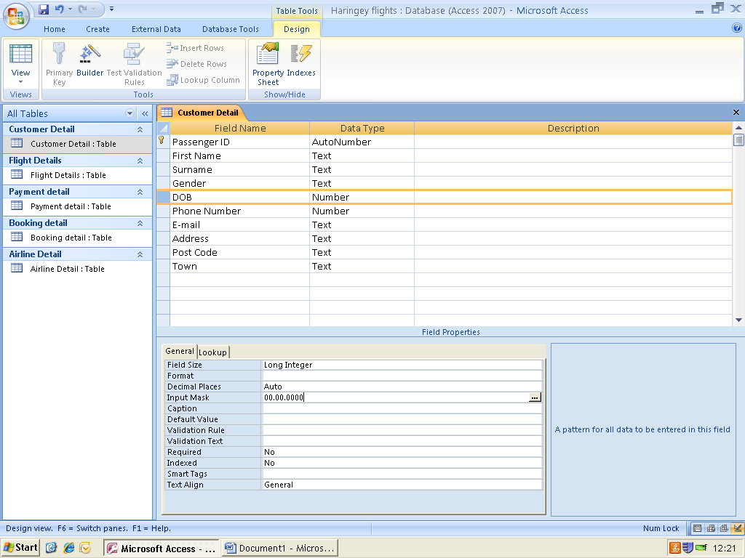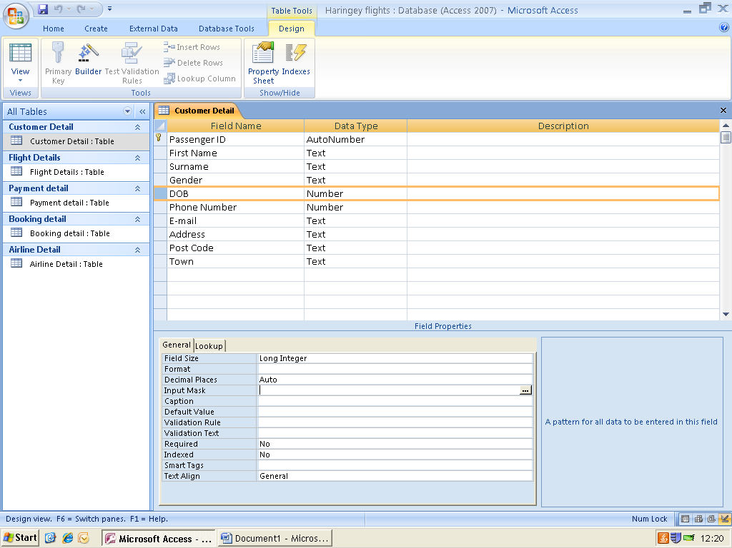

An input mask determines what type of data is able to be inputted into certain fields, for example as shown above an input mask has been set for the DOB field showing the type of format the date should be set in (DD/MM/YYYY)

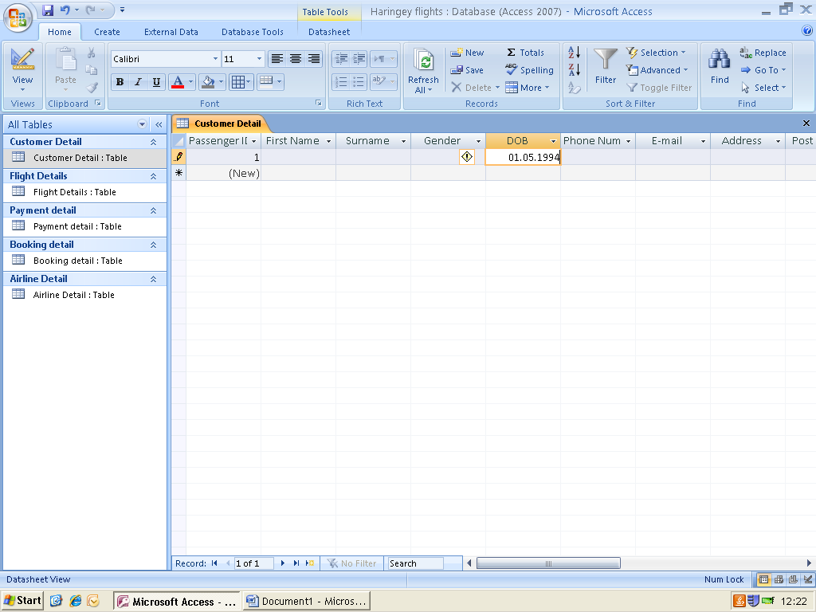

Once previewed in the datasheet view, due to editing the input mask in the design view, once filling in the table it will be in the form set of (00/00/0000) as shown above

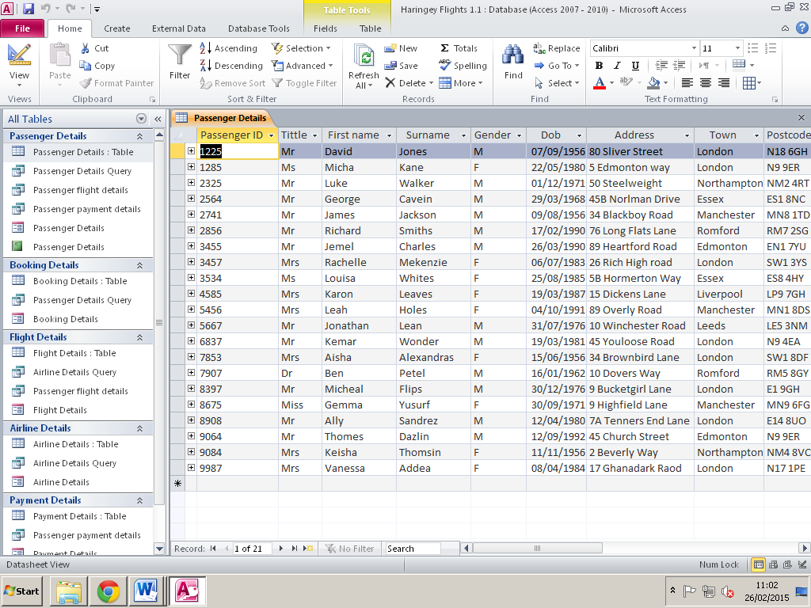

Finally this is the passenger’s details displaying all the information of all passengers

**Integrity of data**

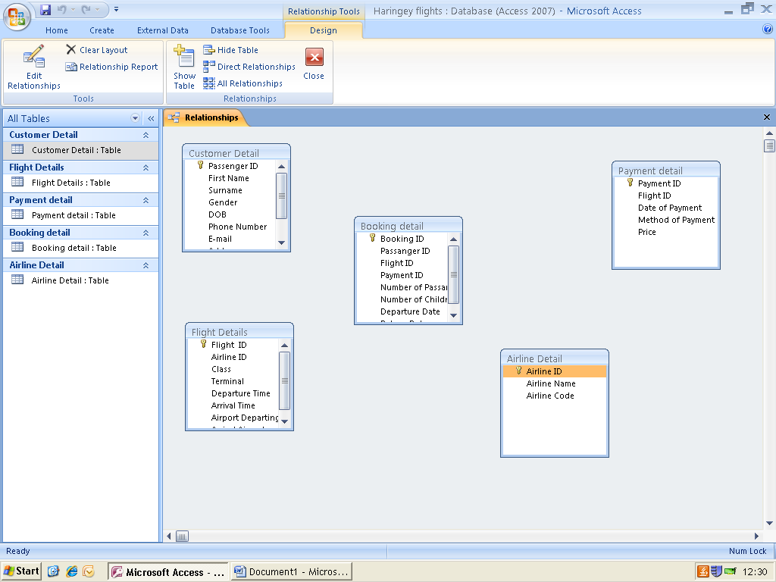

What is being shown here are all the tables created within the database

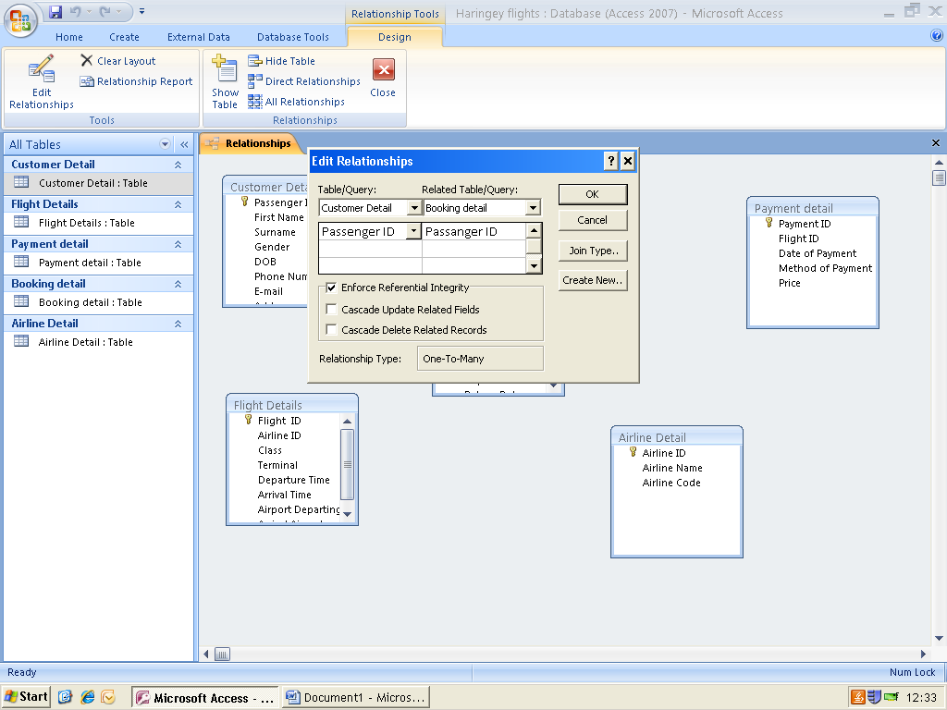

I have decided to link the tables together by creating relationships

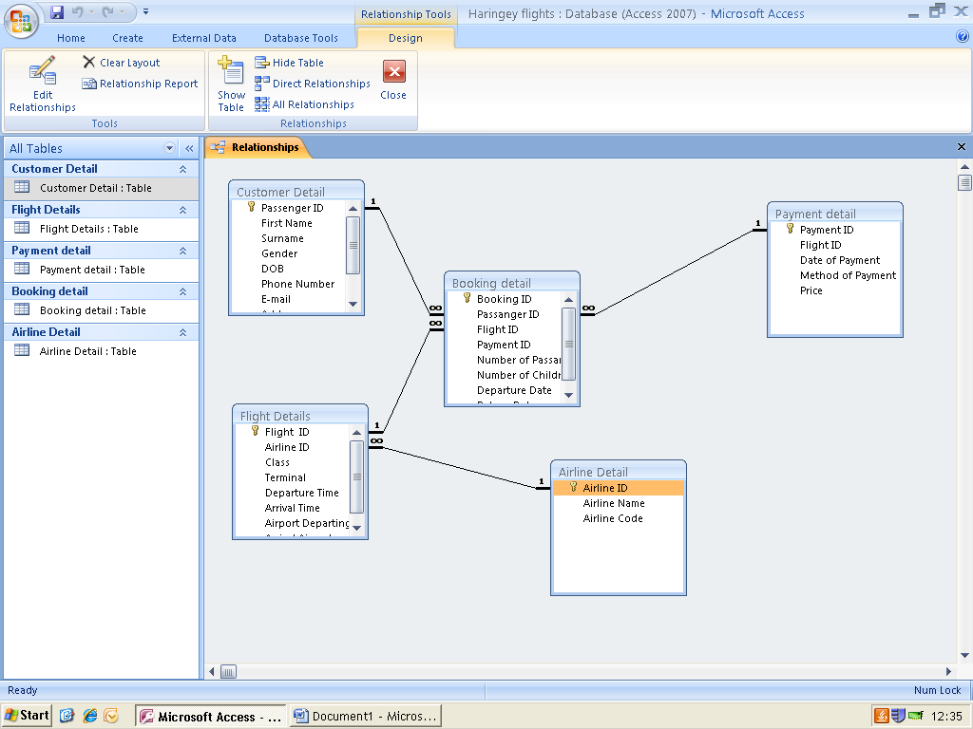

After choosing and editing the relationships the tables should have, this is the result that has been chosen, being one to one, many to many and one to many