Organisational Systems Security

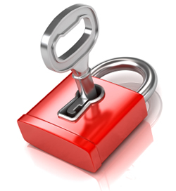

Lock & Key security

Lock and key security systems ensure that all rooms and buildings are secure under the lock and key system. Keys would usually be handed out to staff and would be recorded down in a book so that the organisation would know who has access to which rooms.

Staff/Visitor passes

Organisations use ID cards as a method of entry which allows people to gain access into buildings as long as they carry their cards with them. If in (for example) a college, ID cards that are issued to staff would allow them to access all doors in the building, whereas a students card wouldn’t.

Visitor passes would be given to visitors on a temporary basis and would only allow them to have limited access into that building.

Sign in/out systems

Sign in and out systems rely on staff using swipe cards or dongles. This allows the system to know exactly who has swiped in and out at what time and also keeps track of who is actually in the building.

Equipment Identification

In some organisations, for example a college, in an ICT room all the computers would have numbers on them so that the technicians can be able to identify them if something were to go wrong, or if it were stolen the college will know exactly which one was taken.

Security Personnel

Whether it is a college or a supermarket, organisations hire security personnel to prevent crimes happening caused by people. They stop offences like assault, vandalism and robberies that could occur, preventing them from happening.

CCTV

CCTV used in buildings keeps surveillance on the building to deter and detect crime that could happen in the building, for example if people were to come in and steal the businesses computers, the CCTV cameras could capture footage of who has committed the crime.

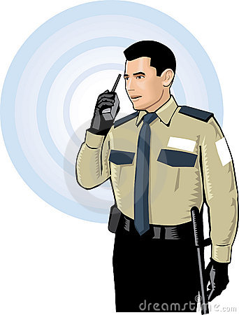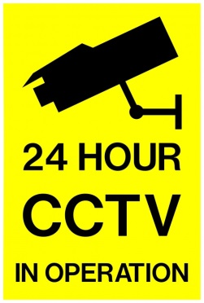

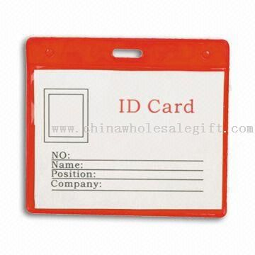

Biometrics

Fingerprint recognition

This type of identification is carried out by either scanning a person’s fingerprint for being able to identify them in an organisation (for example in an organisation a staff member would have their fingerprints done, and would use this in order to access certain parts of a building), or can be carried out by having someone dip their hand in ink and placing their finger on paper, and this method is mostly used when someone has been arrested and has committed a crime.

Retinal scans

These scans are used to identify people (in this case staff that work in an organisation), and is done by scanning the retina of the eye. This is a very useful and unique type of identification as everyone has a biologically unique configuration.

Iris scanning

Aside from retinal scans, iris scanning is where the iris of the eye is scanned (and unlike retinal scans glasses and contact lenses can be used in this process) and is more likely used in international destinations.

Voice recognition

This is a form of biometric access control, but may not be as efficient as some other biometrics such as fingerprint or retinal scans. The reason for that is because as people grow (broken or higher-pitched voices) or even when we experience different emotions such as being stressed, there may be times that our voiced may not be recognised due to these little things, and so the person would have to repeat what they’re saying in order to gain access. Nowadays voice recognition has improved as it is now used in games, for example the Xbox 360 Kinect uses voice recognition in games, and speech to text has been made easier to use for people with disabilities.

