Backing out procedures
Have you…
Saved all your work before uninstalling software
Find and click the cancel button in order to cancel the installation
Turn off the computer
Format the hard drive in order to delete all software located on it
Restart the computer and select “Last known configuration”
Use the control panel/add and delete software to uninstall the software
Below are backing out procedures that I have listed in the table below that can be used to back out of installations and upgrades.

Example of a backing out procedure
Here is an example of a backing put procedure using the control panel to uninstalled software that have been installed onto a computer.
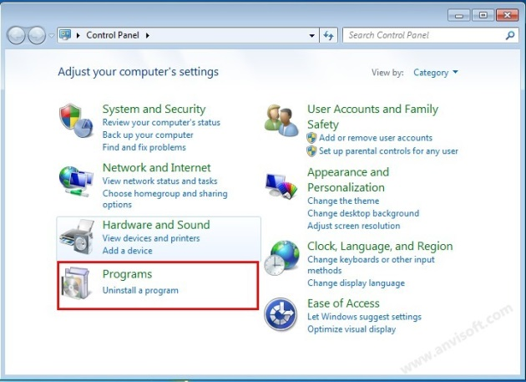
This is an example of uninstalling software using the control panel. By doing so, all the user has to do is go to their start button and locate the control panel then click on the option “Uninstall a program”. After doing so, a page will come up with a list of all installed software. By clicking on the chosen software, above it will have highlighted the button “uninstall”. If the user wishes to continue, they should click uninstall and carry out the uninstallation process.

The software that I have installed is Nero 2015. Whilst going through the installation process one of the first backing out procedures that I could have gone through is by pressing the cancel button before clicking the install button. As I had gone through with the installation another backing out procedure that could have cancelled the installation was to switch off the computer which would have cancelled the whole process. With an upgrade, using the canel button will automatically cancel the upgrading process and would leave me with the previous version of Nero 2015 that I have already got installed. As mentioned above, if the software has been completed and I would like to remove it from the computer, I can use the control panel to completely uninstall the software, removing it and all of its components off of the computer.

