M3 – Test the functionality of an upgrade system you had performed
D2 – Evaluate the performance changes to the computer system after hardware and software upgrades.
Adobe shockwave player for Internet Explorer
The first thing that I do to test the functionality and performance change is by clicking on the internet explorer icon on my taskbar. Instantly it loads up.
As soon as I open up Internet Explorer, I notice that it has Google Toolbar installed (as it was part of the upgrade of Adobe Shockwave Player), and so a popup box appears asking whether I want Google to become my default search provider, because I do, I click OK.
What Adobe Shockwave Player does is allows computer users to view animations online, and also use shockwave to play and access online games better with its software. Therefore, I am going to load up a gaming website called Miniclip to test whether it loads up games fast or not.

Loading up the website was fast, but as I am testing the functionality of the software I have to test a game, therefore once on the website I click on a game called “Commando 2”. Once I click on the game it goes from the white screen straight to the game in seconds which is exactly what I should expect. For any performance changes, what I can evaluate is that playing games online is faster, but other than that the software hasn’t had any other effects on the computers’ performance.

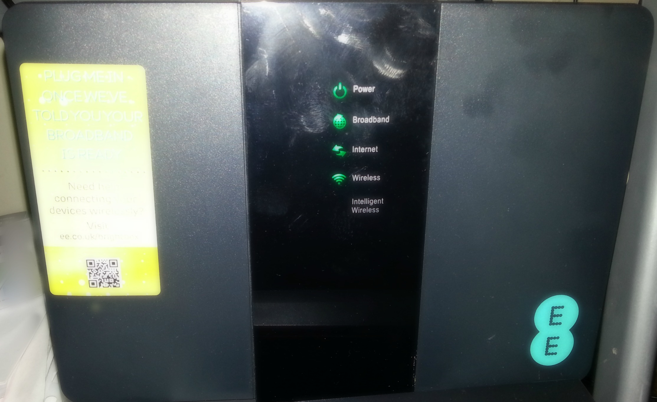New modem, Internet connection
The first thing that I do to test the functionality of the new modem that I have installed is by checking if it is working. As all lights are on indicating that it is both switches on and connected to the internet, I refer to my computer system to see if everything is working well there.

On my computer system it shows that the modem is successfully connected to my computer and that I am also connected to the internet.

Another way to test the functionality is by opening up the internet to see if I really do have access to the internet. So to test if it is working I open up internet explorer.
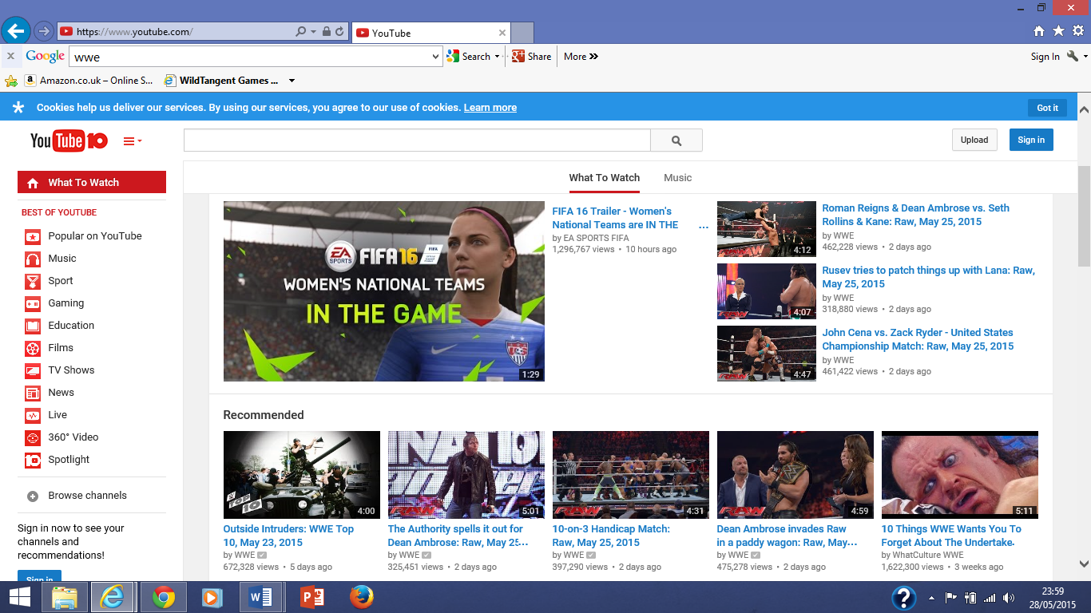
As you can see above I am on the website www.Youtube.com and because it is showing up it means that I am connected to the internet and have access to it.
Another thing I am testing is if the internet loads up faster, what I have done to test this is that I have clicked a video and it has instantly loaded up the page. Once on the page the video begins instantly and already is loading fast.

Therefore by this short evaluation, what I have noticed that by upgrading this piece of hardware, the changes that it has done to my computer system’s performance is loading up my internet browsers’ webpages more quickly, and downloads content on a webpage quickly, for example in the image above I have mentioned that by clicking the video it loaded up very fast, this means that the upgraded modem has faster download speed, which is a huge benefit for computer users that love to have a lot of tabs open in their browsers using the internet for multitasking as it means all their pages will load up quickly.
Other than internet browsers, by upgrading the modem, it effects the performance of internet-based applications such as Netflix. As Netflix relies on internet connection to be able to stream their movies and TV Shows, as I have upgraded to a faster internet, this means that the performance of Netflix will be boosted. For example, whilst watching videos on it will load them faster.
Overall the two upgrades that I have performed have only had a few minor performance changes to the computer system.

