Improve the effectiveness of a website on the basis of a client review
I have asked a client to review my website, asking them to provide me with improvements that I can then use to improve my website.
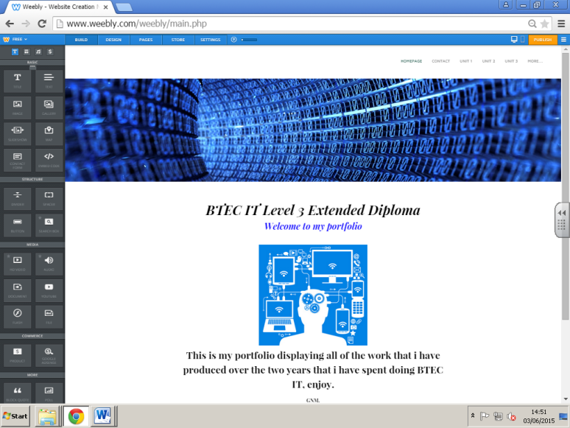
On my homepage, it was given some positive feedback, and had no improvements whatsoever to be added on.

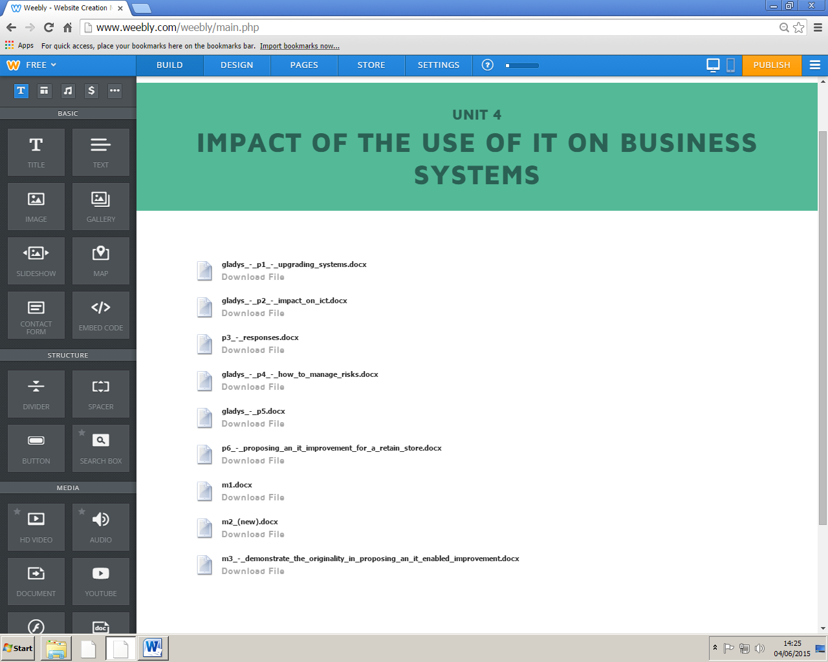

Whereas the only page that had suggested improvements was one of my unit pages.

The first improvement I was suggested was to change the header font to white so that it could match the header colour on the page (also so it can match the white and green colour scheme). The second thing was to rename the files downloaded onto the website, and name them correctly, because as you can see, it looks like it has been exported directly from my documents, and hasn’t been touched ever since. Thirdly, another improvement was to add headings to separate the pass work from the merit work, so that everything can be organised. Lastly, I was asked to add an image.

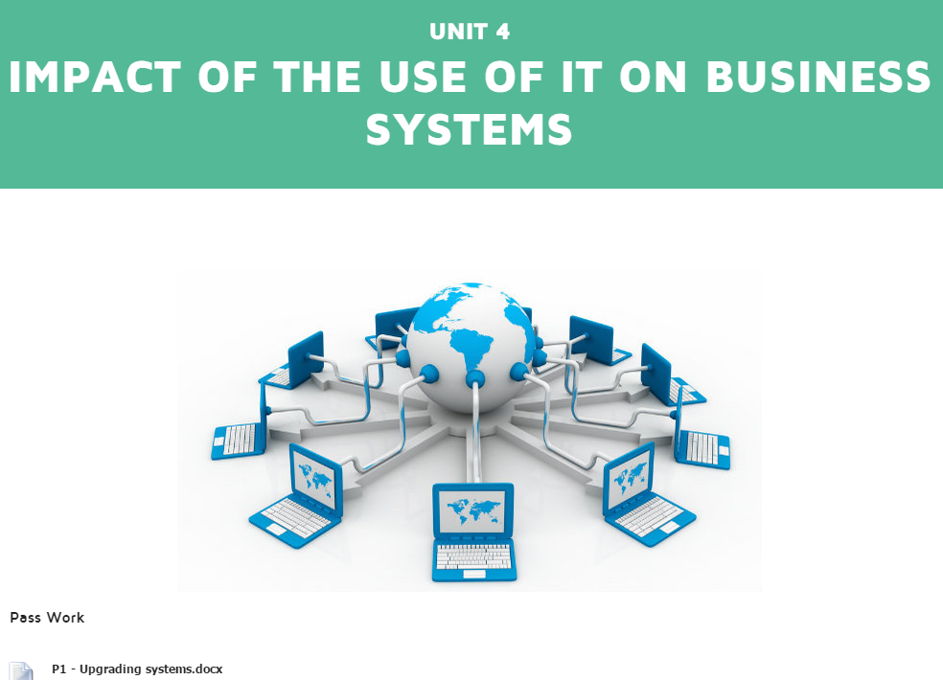

After taking in the improvements, I firstly changed the colour of the font of the header from green to white, and then added an image, to make the page a bit more interesting.
I have then fixed the names of the files, making them seem more fixed and that I actually care about the way that my site looks. Also what I have done is added in the headers as asked to do, separating the pass work from the merit work, making my work look more organised.

