Demonstrate the originality in proposing an IT enabled improvement
One problem that having a 3D printer is that is uses far too much energy. A 3D printer contains components such as cooling fans, stepper motors and lasers, all used as part of the process in making the end-products, of which has been requested, for example a plastic action figure. The cooling fans would take up a lot of electricity as well as the motors being used as part as the process of making the plastic, and also by having lasers, being used to heat and melt plastics. All together this takes up a lot of energy. 3D Printers can cost up to $10,000, although efficient as it can print out many plastics that can be convenient for the user, the 3D Printer is known to be energy hungry. By printing items such as a plastic chair, and with the use of heat and lasers using energy to carry out the process, and five or more stepper motors working inside the printer producing a lot of heat that would be consumed by the cooling fans, it takes up twice the amount of energy made for getting it manufactured at a regular factory.
A way to improve energy consumption is by having the printer rely less on energy. A way to do this is by having the printer rely on fewer components such as less stepper motors. Stepper motors rely on electricity to run, and in a 3d printer there can be up to five stepper motors running in a printer, moving parts around in the printer as part of creating and producing what is being made. Also as stepper motors produce heat whilst working, this means that more cooling fans would be needed, taking up even more energy whilst the 3d printer is at work. Therefore 3D printers should not require many stepper motors as it consumes too much energy. Having less stepper motors would reduce the use of energy taken up by 3D printers.
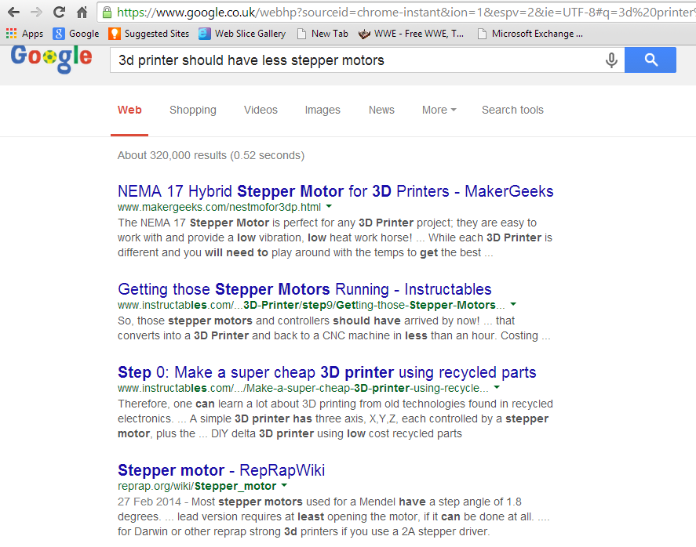
As this solution is an original idea, I have used Google to search up if my idea of having less stepper motors has been used. By looking at the results, no results show that my idea has been used, therefore making my solution an original idea.
This evidence shows that my idea of having less stepper motors in a 3D printer is an original idea.

