Explain the tools and techniques used in the creation of an interactive website
Concept designing
When designing a website, you can consider using two design tools: mood boards or storyboards. A mood board can be a collection of pictures, text and other materials all based on the type of project you are focusing it on, for example, if creating a website based on ICT you would consider collecting images of computers and its components, technology, and brief text relating to ICT. For a website you would produce a mood board based on what you are creating the website for, giving it the same feel as a website. Storyboards on the other hand are used in website designing to structure the website, being able to see step by step where to put what on the website. For example you are able to use storyboards to design a specific page on your website (where you’re going to put an image on the page, where the text is going to go), using it as a guide for the website.
Layout techniques
By using tables, frames, DIVs and SPANs, these are all methods to arrange items on a web page, and these are all important factors of being able to design a layout for webpages. Tables are used to hold the content of the page together, for example, in a table it contains cells. Each cell contains individual content, such as images, each image on the page would be placed in an individual cell in the table (cells can also contain text and buttons). By using frames, each section of the web page will be divided into their own files, for example, the header would be known as header.html. DIVs and SPANS are used to define a style for a block of HTML, (DIVs include paragraph breaks, whereas SPANS do not).
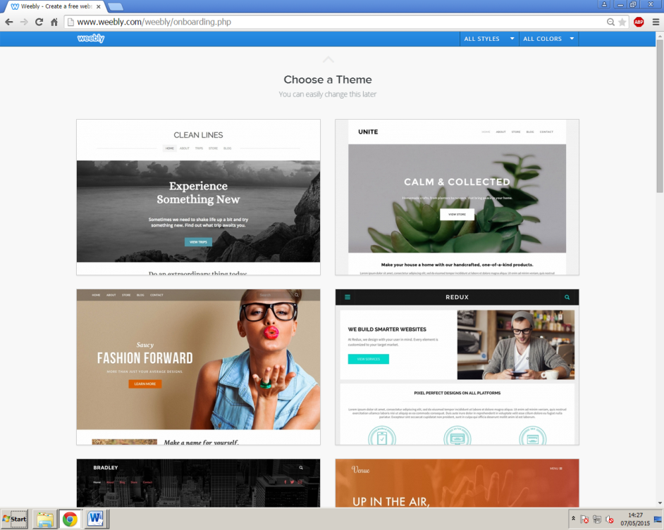
Templates
For websites, a useful tool would be the use of templates as they provide users with a basic structure, made for adding content to the page an easier process. For example on websites like Weebly which users can create blogs or websites on, they provide users with templates to get users started with their site.

Colour schemes
When it comes to designing websites, what users must consider is using colour schemes, and good ones. For example Facebook’s colour scheme is blue and white, sweet and simple and is also memorable as they use it for their headers and logos. Colour schemes include having appropriate colours, readable text for all types of users, and should overall have an attractive look that pleases users going onto the website.
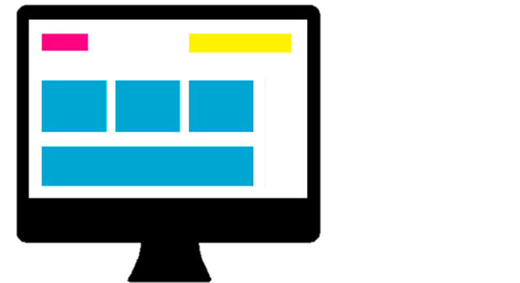
Screen designs & Outline of content
Screen designs are used for website designers to picture exactly how their website will look like before actually going on to create them. For example, the image on the right shows a screen design for a website, indicating that there will be images on the page, a possible logo, maybe even a header, but this is the type of screen design that web designers will create to plan how they will create their website. With outlining content, the only thing that could be outlined so far are the headers that will go on the page (and once actually creating the page, that’s when information backing up the header will go onto the page).
Markup languages
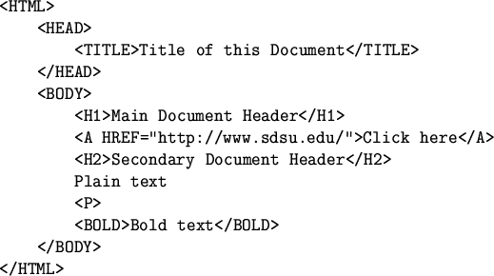
Markup languages are used in the process of web development. They are used in a way that text is annotated, and manipulated by the computer, for example with a markup language you can write text into the tags and (like in the image on the right) make text bold, then once being previewed on the webpage, that text that was written to be bold in the markup language will appear bold on the web page. The most common markup language used is HTML. By using HTML you are able to use it for formatting, the style and layout of webpages, text and images. Without the use of HTML, the browser wouldn’t be able to display these things properly, for example it wouldn’t know whether to display text as text or images. With HTML they use these tags <>, and have <HTML> at the top and bottom of the code (just like in the image above) so that the webpage knows which markup language has been declared.

Client side scripting language
Scripts are languages that are executed on the users’ computer, so in this case it will be processed by the users’ web browser. For example, JavaScript is a scripting language that can be used in HTML, which is used for designing websites. Scripting languages are created so that when designing webpages, they are used to bring in more advanced features. So for example, when the webpage is loaded onto the users’ computer, the script will begin running.
Features and advantages of software languages
CSS (Cascading Style Sheet) is used on webpages to format the layout. It can also be used for formatting across the website, which would make the website much more easier to maintain, for example with CSS you are able to transfer designs from a webpage on your website onto another webpage you are editing by linking the CSS on the webpage you are transferring the designs to, which would be the main advantage as you would be able to do this for every other page on your website. Languages such as ASP (active server pages) and PHP (hypertext preprocessor) are server side web languages, executed by the use of the web server’s processing power. An advantage of these two languages would be that on a website they create interaction, for example the PHP language allows website designers to use the language for creating websites linked to databases.
A client side web language such as JavaScript is executed by using a user’s computer, and can be used for interaction, for example you can use JavaScript on a website for users when they are filling in forms.
Software development environments
Using software development environments means that when designing websites it helps make coding the site a quicker process, and also makes formatting easier. For example Adobe Dreamweaver provides website designers with tools for creating their website, and also supports client and server side scripting languages to aid the user in creating a good, yet interactive website.

