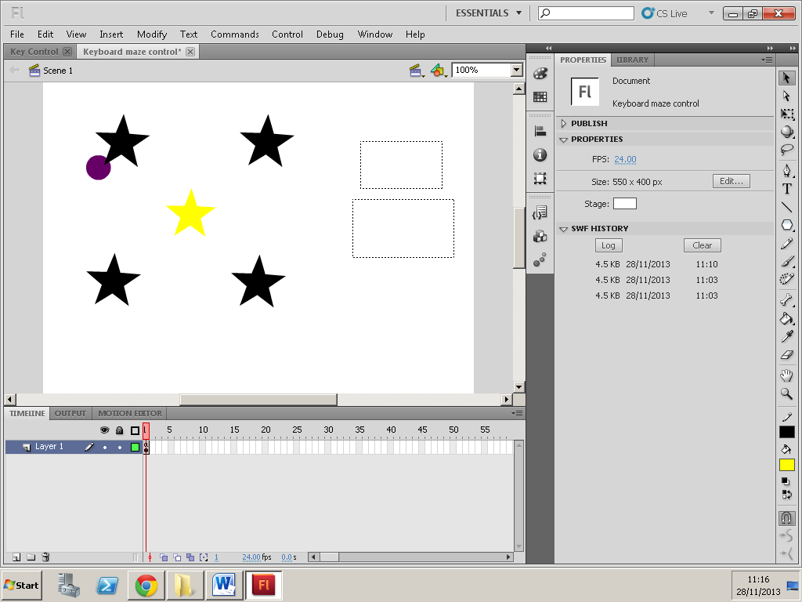

Purple ball operated by the keyboard events

Here in this box my score comes up, every time the ball hits the yellow star the score adds up by 10

This box is where the word “wow” shows up when the ball hits the yellow star

Yellow star is called hello, when the purple ball hits hello, the word “wow” will appear and the score will show

Four black stars (and yellow star) created with the polygon tool

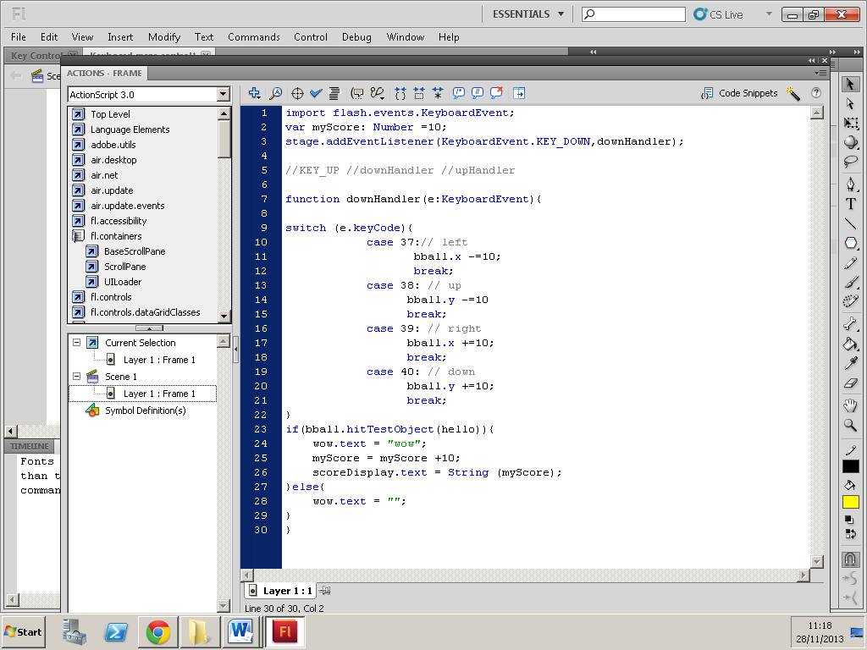

The hit test is where my ball would hit the hello object and the word “wow” will appear along with my score, which adds up every 10

Ball moves left 10px for every event  
“break” – stop here and exits switch statement

This acts as a switchboard to check key code value and direct to the correct action block

This declares the function called “arrow keys”

On this line, an event listener has been added and the event added is a keyboard event