Terminology
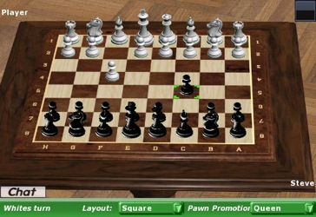
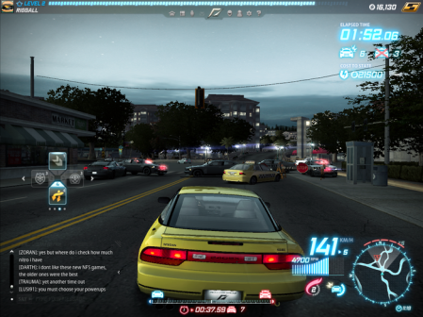
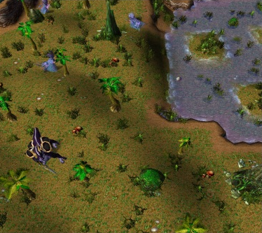
Visual style terminology
World – a world can be the setting of which the game is played and it could be either a terrain world which is a world made up of landscape/natural features like ground, soil and rocks for example in the game World of Warcraft it is set in a terrain world. An architecture world that is made up of buildings or an objects world that including objects like tables and chairs, for example chess, as it is played on a table which is an object
Characters – A person, group or a thing that is controlled by the player
Non-playing character – A game character controlled by the computer/computer controlled character, which can be for example when playing a game like Fifa, as you are playing as one team the other would be controlled by the computer “COM”
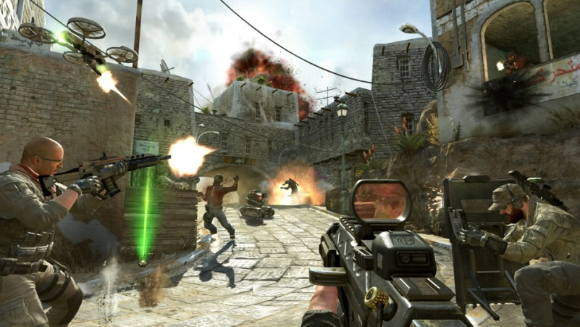
Perspectives – The way you see something, in this case the way the game is seen whether it is two dimensional or three dimensional. Perspectives can be seen as bird’s eye view or from the eyes of the character (1st person), for example in Call of Duty, you cannot see the character but what they are holding and everything else around them

Interaction terminology
Interaction model – the way the player interacts with the game for instance when playing with an avatar you are able to run jump and pick up objects
Single player – A game which is made for only one player, in video games there is a story mode which is made for single player use
Multiplayer – A game designed to be played by two or more players for example in games like WWE Smackdown vs Raw up to four players can verse each other or fight together on teams
Narrative – a spoken story that helps instruct the game player, it can be like a guide that helps the player progress in a game, for example in Shrek 2 the game a narrative is being spoken to the player letting them know what they have to face when the level loads up
Game setting – how the game looks, the features you can see whether it’s environmental, physical or ethical. Or a set of options you can select and change to make your game more enjoyable
Goals – A specific aim to accomplish a mission or task
Challenges – Extra tasks that are set in games that can be completed optionally for example in New Super Mario there are mini games
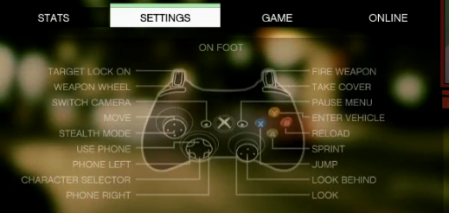
Rewards – After reaching an aim, a reward is a gift given as an achievement, such as extra lives or extra points for achieving goals or finishing levels quickly
Player actions – When you make your character in the game run walk or talk by doing such things like (for example in the game GTA V) on an Xbox controller you would have to make a character run by pressing the “X” button or moving your character by using the lest analog stick
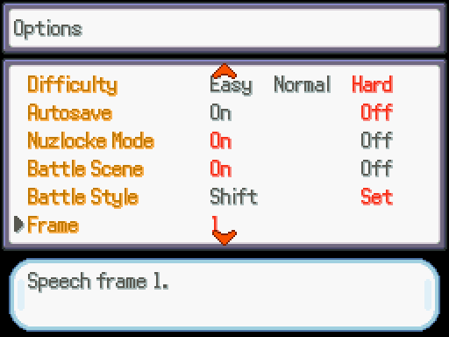
Rules – Regulations that has to be followed in order to play a game/to be able to do something
Difficulty – selecting which type of difficulty you want to play your game, how hard or easy you want it to be, so for example in the game Pokémon survival island there is a difficulty option that players can select to make the game easy, hard or ever hard
Game mechanics – Is the interaction between the player and the game, it the player being able to use the game being able to do actions and completing challenges
Balance – Fairness between characters, for example in a multiplayer game, all characters start off as the same level at the same strength, but as a character evolves, its strengths and levels grow too passing other characters because they’re on a different level to them
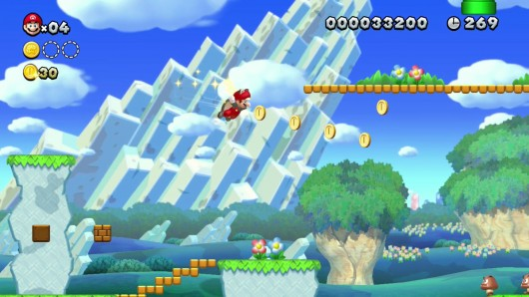
Feedback – when you play the game and it shows you the game information, such as lives, score and how much time you have left, for example in an adventure game like super Mario there will be feedback showing lives and the players score
Game structure – How the game is set out, these will include what the game has – Main menu, rules, starting the game/tutorial, playing the game, sound, characters, save &load game.
Addiction – Getting hooked on a game, the game being so good that you want to continue to play the game until you reach a certain level or high score, usually game designers will try to achieve game addiction so customers will continue to buy their games

