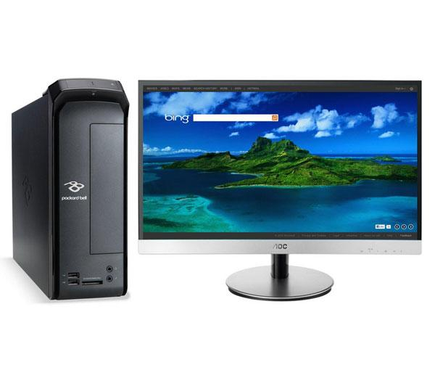
PACKARD BELL iMedia S2185 Desktop PC & AOC i2369Vm Full HD 23” LED Monitor with MHL - £459.00
Functions:
- AMD A4-500 APU
-long battery life
-Fast performance
-Amazing graphics
- Windows 8
- Hard drive: 1 TB
- Memory: 6 GB
I would recommend this computer because it has AMD processing which allows users to multitask speadily, Windows 8 is the operating system, and along witht that it comes with superb graphics due to the iMedia S2185 that comes with NVIDIA GeForce GT graphics card that delivers fantastic looking graphics that gives users an advantage when playing games or whatching DVDS. The PACKARD BELL also comes with excellent connectivity with up to six USB ports for media devices, memory sticks and external harddrives to be connected, and has built in WiFi and Ethernet connections for internet use. As this computer comes with an AMD A4 APU, it has the processor and graphics card on the same board, providing the user with well-organized computing as it helps save space well. If you enjoy saving music, images and plenty of documents on a computer, choose the PACKARD BELL iMedia S2185 as it comes with a 1TB hard drive. It also comes with 6GB DDR3 RAM, HDMI and DVI video interface, an optical drive, and accessories including a keyboard and mouse.
This product was chosen because although quite cheap for a desktop PC it comes with good features and is suitable for any type of user, as well as being used for everyday computing. So overall I recommend this computer.
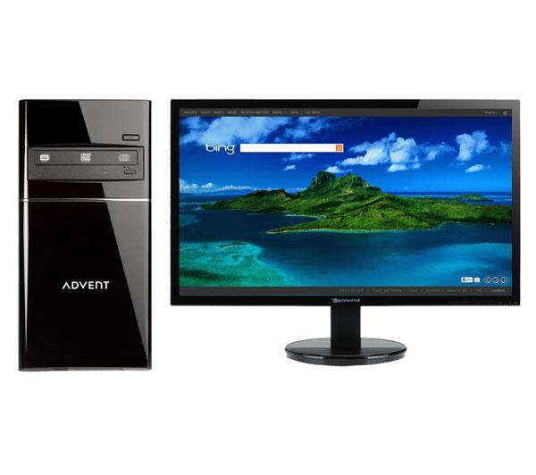
ADVENT DT 3411 Desktop PC with PARKARD BELL Viseo 233Dbd Full HD 23” LED Monitor - £599.00
Functions:
- Intel Core i3-3240M processor
- Windows 8
- Hard drive: 2 TB
- Memory: 8 GB
As the ADVENT DT 3411 is powered by Intel Core processor, has a Windows 8 operating system and provides users with perfect web browsing, word processing and the use of social networking and the ability of multitasking. This PC comes with enormous memory (2TB) best for saving files and programs and plenty of media. The graphics card comes with enhanced visuals that allow users to enjoy watching films and gaming. It also comes with touch screen. With the Windows 8 operating system you are able to simply touch an application/programme to open it and enjoy the experience. With Ethernet ports internet or gaming connections are available for users. As it is made for multitasking, the RAM comes with 8GB or DDR3, and is compatible with touch screen, being even more user-friendly with users. It also comes with accessories including a wireless keyboard and a wireless mouse.
This PC is best suitable for gamers and for users who enjoy the use of the internet and social networking sites.
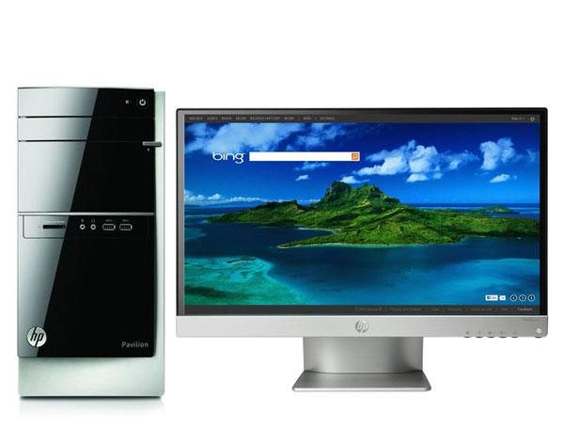
HP Pavilion 500-141ea Desktop PC with 23xi Full HD 23” IPS LED Monitor - £549.00
Functions:
- AMD A8-6500 APU
- Windows 8
- Hard drive: 1 TB
- Memory: 6 GB
This PC comes with a Windows 8 operating system that is powered by the AMD A8-6500 APU processor that features an integrated graphics card and provides such great processing power. As it comes with a 1TB hard drive this allows users to be able to store as many documents, images and videos along with other files as they wish. As a user likes to multitask, this advantage comes with 6 GB of DDR3 RAM. With great graphics it enhances users viewing experience great for gaming or everyday use. The AMD APU comes with an excellent graphics card that provides crisp everyday computing. It also comes with accessories such as a USB keyboard and mouse.
This PC would be great for everyday users that enjoy the use of technology.
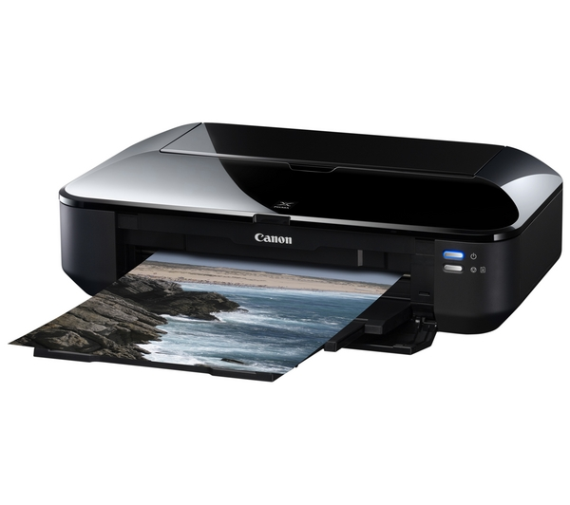
HP Deskjet 3520 Wireless All-in-One Inkjet Printer -£59.99
Features:
- AirPrint
- Double-sided printing: automatic duplex
- Print quality: 4800 x 1200 DPI
- Print speed: 8 ppm
This all-in-one inkjet printer is very useful for frequent printing, whether it is in a household or in a simple office used for printing and copying, along with a Flatbed scanner. The HP Deskjet 3520 comes with ePrint (being able to wirelessly print documents and files from a smartphone or tablet) and AirPrint (from Apple tablets, IPad or iPhones) technology, providing users with quality printing, allowing both double-sided printing and replaceable inks. As well as it being an inkjet printer, it can be able to print in all types of formats such as envelopes, labels, cards and plenty more. It can carry 80 sheets of paper, and weighs up to 5kg.
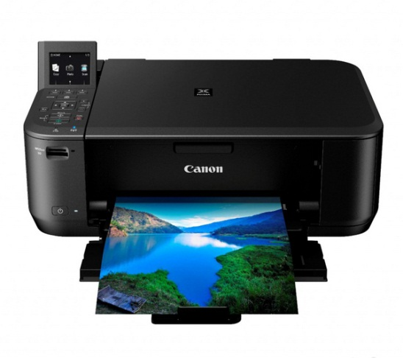
Canon Pixma MG4250 Wireless All-in-one Inkjet printer – £54.99
Features:
- WIFI & Canon Easy-PhotoPrint
- Apple AirPrint
- 4800 x 1200 dpi
- Up to 9 ipm
The Canon Pixma MG4250 Wireless All-in-one Inkjet printer provides users with good quality prints, and allows users to also be able to use the printer, as well as for scanning and copying. When it comes to delivering high resolution prints, the Canon Pixma uses a superior cartridge system that produces 4800 dpi sharp and vivid prints. It’s quick and fast even when printing good quality coloured photos and prints all documents fine. Apart from being able to print such great quality documents/images, this printer can be flexible too. As it is compatible with WIFI this means that it can print out prints directly from the internet, even without using a computer wirelessly. Double-sided printing is available with this printer, as well as being able to print documents from a memory card. It comes with a colour flatbed scanner, can carry 100 sheets, weighs 5.7kg, and comes with software that is suitable for the printer. Nonetheless, I recommend for this printer to be bought as although cheap, it provides the user with great prints and is very efficient for everyday use.

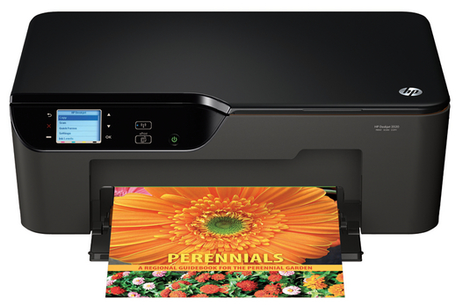
HP Deskjet 3520 Wireless All-in-One Inkjet Printer – £59.99
Features:
- AirPrint
- Double-sided printing automatic duplex
- Print quality 4800 x 1200 DPI
- Print speed 5 ppm
The HP DeskJet 3520 Wireless All-in-One Inkjet Printer can be used for everyday printing in a household and supports ePrint and AirPrint technology, as well as providing users with good quality and double-sided printing. When printing with the HP DeskJet 3520, it delivers full colour high quality prints and even prints out borderless photos leaving users with stunning photo prints with no trimming. You can be able to use ePrint to access printing with this printer from the likes of your Smartphone, tablet, and Laptop practically anywhere. This printer also allows users to print scan and copy, and can deliver prints is plenty of formats. The scanner is a flatbed and the tray holds up to 80 sheets, and also weighs 5kg.

