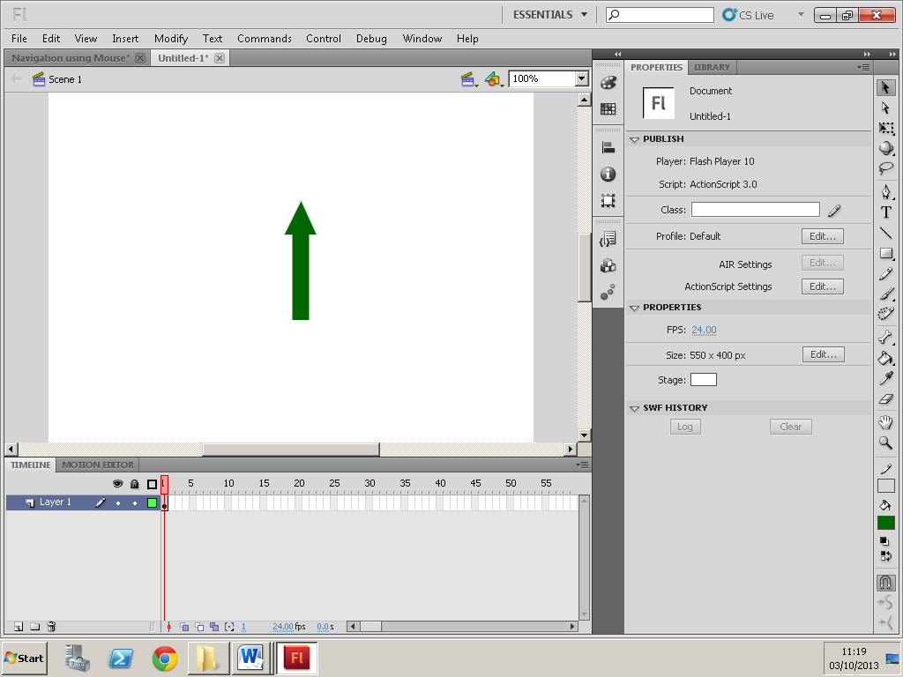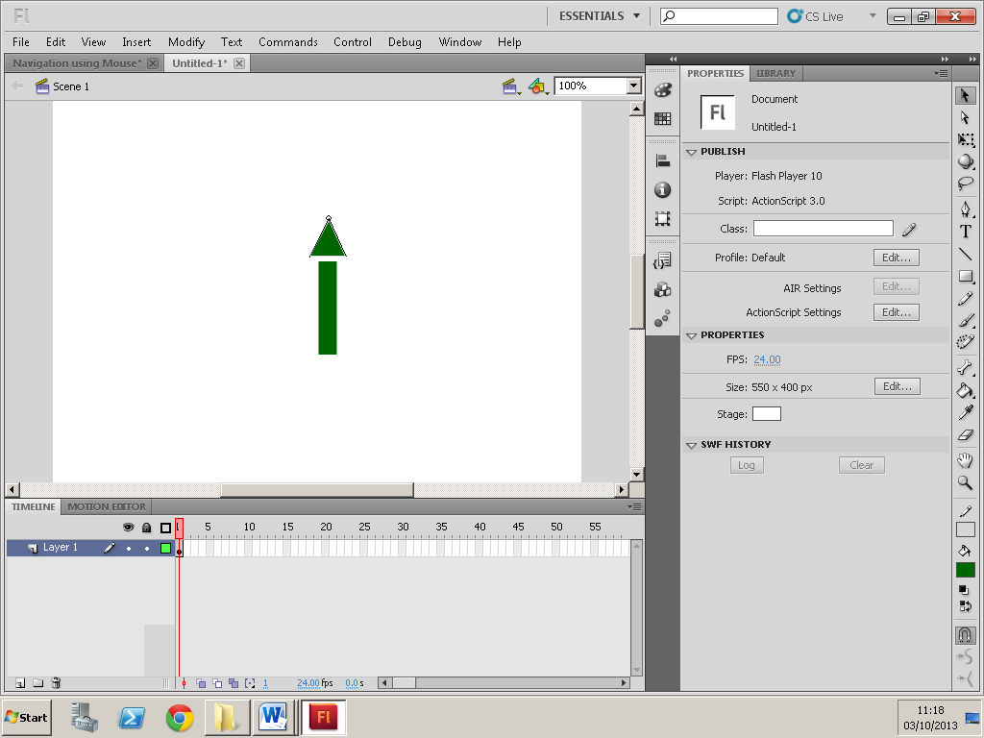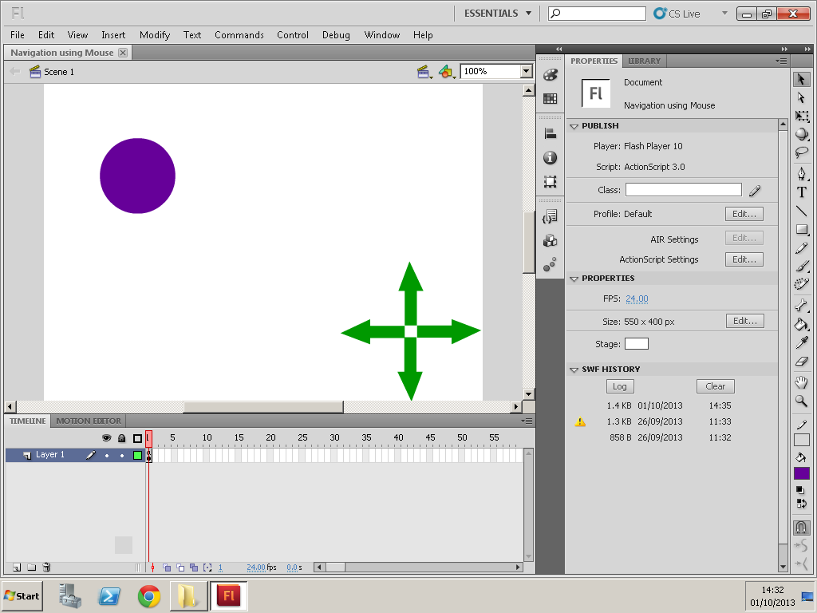

I first made an arrow using two shapes (created by the shape tool) and made one of them into a small triangle. I then coloured them to the same colour and joined the shape together. Once joined together, it means that the shapes have become one.

I created my shape using the ‘Rectangle tool’ and changed the shape into an oval. I then changed the colour

I then made 3 other arrows. After making the arrows I made them all into buttons ‘up, right, down, left’.

I have only used one layer, and no other key frames, just the one.

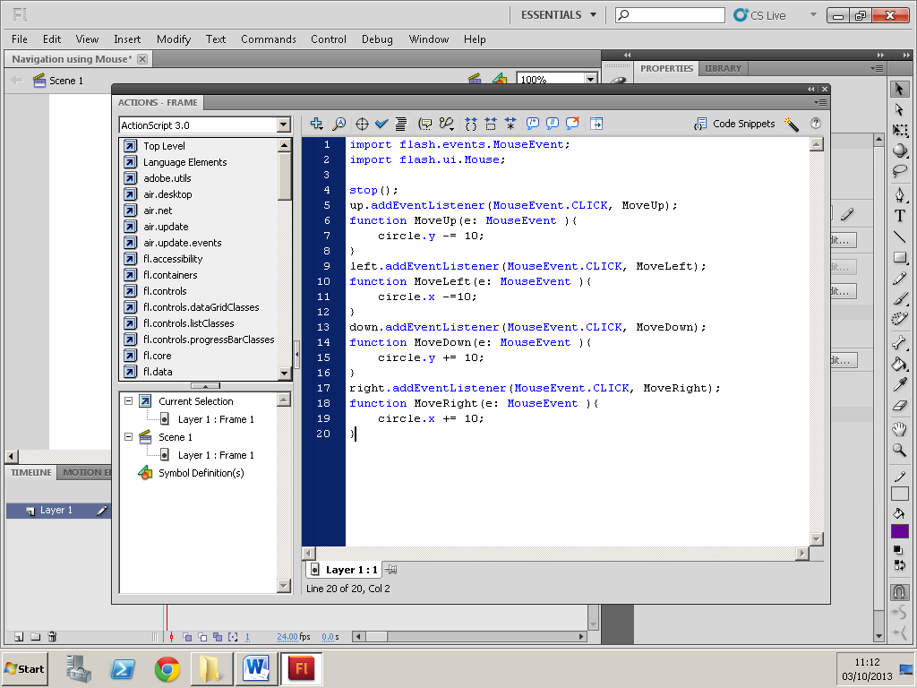

‘Up’ is the name of the button. I have added a listener so that when I click this button it can respond to the mouse event CLICK and actually move my shape up. When the button is clicked, it will function and move my shape upwards. Where it says ‘circle.x -=10;’ those are the coordinates. When it has a minus or a plus it means whether it is moving up or down.

This part is the library of all the events

The same process goes with this process, but instead all the instructions have been changed to make my ‘left’ button go left

The same process goes with this process, but instead all the instructions have been changed to make my ‘down’ button go down

This action stops the whole animation until my action buttons are clicked

The same process goes with this process, but instead all the instructions have been changed to make my ‘right’ button go right