Here is another shape created by the rectangle tool

I first created a shape using the ‘Rectangle tool’ and changed the shape into an oval. After I decided to change the colour to blue.

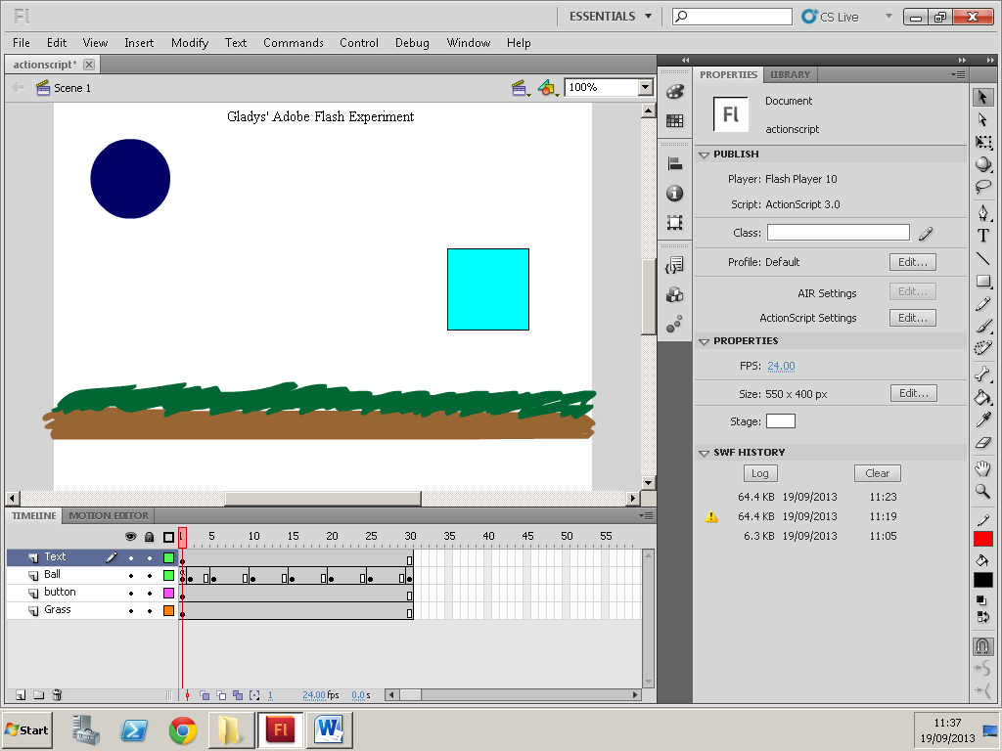

To get text I selected the text tool and chose which font and size I wanted to use.

My Grass and soil were both made from the brush tool, then I selected from the fill selection a brown colour for the soil, and green for the grass.

These are key frames, and I have 8 of them. In each one they show how my animation is moving, the first is where my ‘ball’ first starts out start, and the last is where my ball has ended up last.

These four are called Layers. Each layer I’ve used with text, shapes and drawing. The first is text, Second called ‘ball’ is used for the dark blue circle, third called ‘button’ has the lighter blue shape and is used as a button that allows my animation to play, and last layer ‘Grass’ is used for my soil and grass.

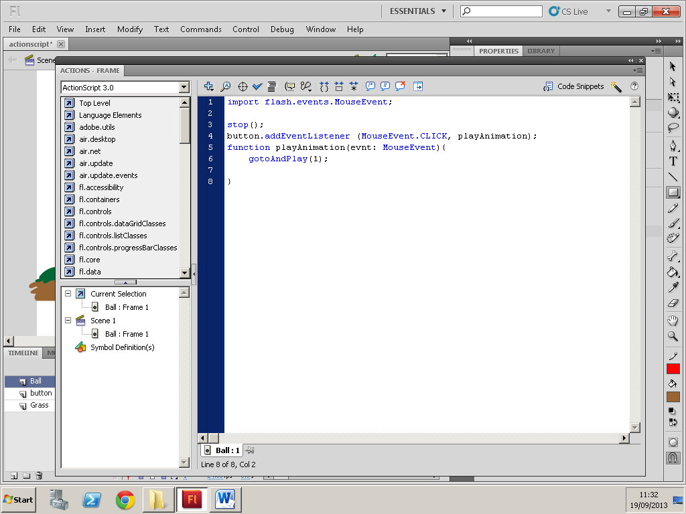

The library that contains functions my program is using

A function that stops the whole animation

For the interaction to work, I have given the button a name, an event listener, handler and the right settings to make the event handler work.

The button has a listener, so when the mouse is used to click on my button, it will listen to the CLICK action and move onto the ‘play animation’ function.

The function ‘playAnimation’ will work when the button is clicked, and after it is clicked it will play the animation