Demonstrate that a created website meets the defined requirements and achieves the defined purpose
In the scenario of the assignment I was given before creating my website, I was asked to produce an online portfolio for uses such as presenting it to a future employer, showcasing the work that I have produced over the two years I have spent doing IT.
It was required that I create a homepage for my website, create pages for each unit in my course that I have done, give a description of what was done in each of those units and what was learnt from them, have an example of work uploaded onto the page that can be downloaded from the site, and lastly a contact me page which allows visitors to contact me via email.
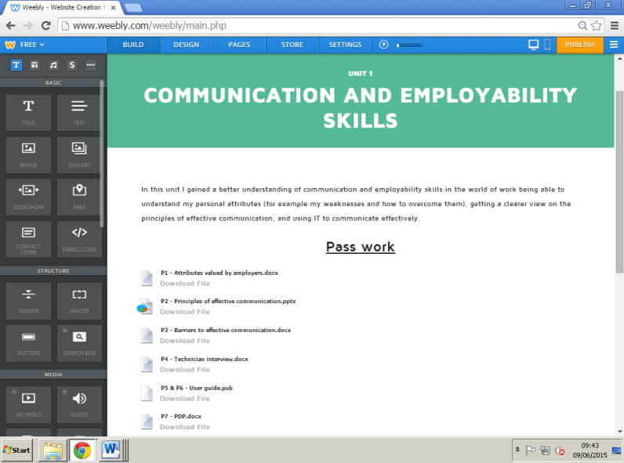
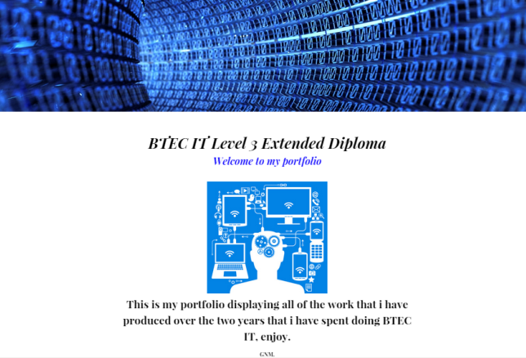
Firstly in order to meet the requirements I obviously had to create the website (using www.Weebly.com), and pick a template that not only I likes, but would still also be satisfying to visitors that would go onto the page. Doing so, the first page I officially created was the homepage. I picked a header representing IT (since that is what my whole portfolio would be showcasing), added a title, text and an image to make my homepage seem less plain, and explained briefly what the portfolio was about.
Next I had to start creating the unit pages. Every unit page has the same similar design and layout, so there was no need to plan ahead or change each and every page in different ways. Therefore in the unit pages I specified which unit it was, gave the title of the unit, a description of the unit, and what I have learnt from it, then went on to upload all of the work I had created for the unit (and as mentioned above I have done this for every other unit page).

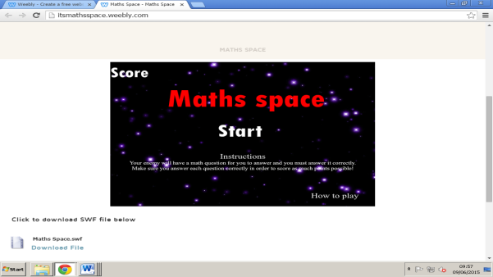
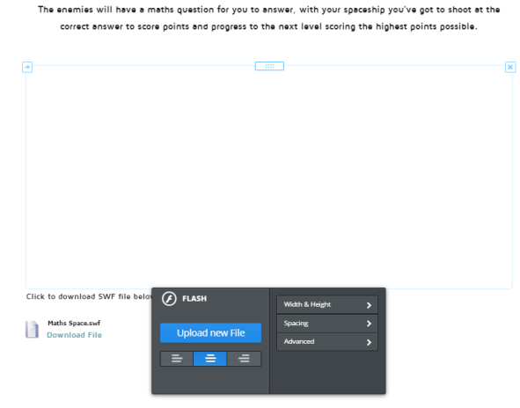
Another thing that I had to do in order to meet the requirements of creating this portfolio was to upload an example of work, so in in this case I uploaded a Flash (SWF) file (which is a game that I created), that visitors can play online, yet download for them to play later. In the process of creating the website, as you would have to upload the Flash file, you aren’t able to view the SWF file until the website is published, so after publishing the website I am able to see and play the flash file on the website, as are visitors, which then they are also able to download the game for later use.
*PUBLISHED
WEBSITE*
Lastly, what was required was to create a contact page for visitors that feel the need to contact me if they have any queries about the website, and content published on the site. Therefore I have suggested that if visitors do have queries about the website, they can simply contact me via email.
Overall, by looking back at the assignment brief, I have officially met all of its requirements to creating an online portfolio.

