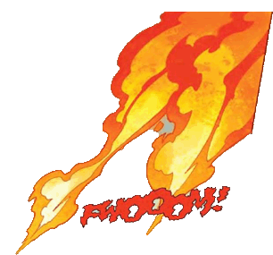
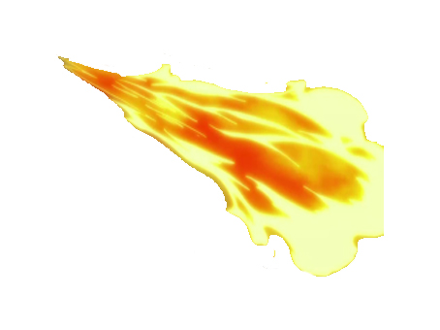
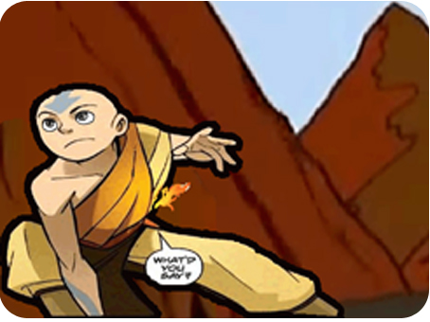
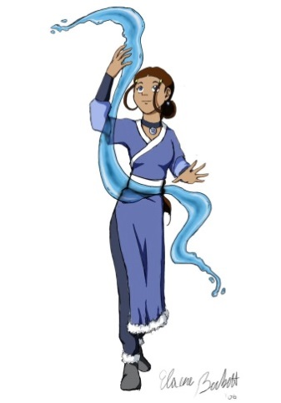
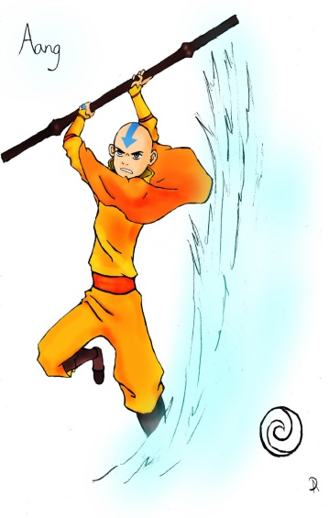
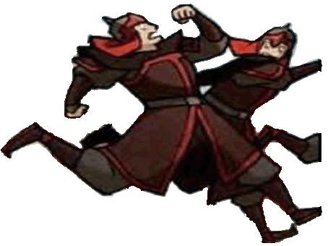
Avatar – The Promise
Stop
Play
Replay
Pause

The reason why I decided to go with adding pictures on both sides of the kiosk is to resemble exactly what happens throughout the animation. The two main elements in the animation is fire and water, also the main characters are the soldiers and Aang and Katara (the boy and girl). Also I decided to have my stop pause play and replay buttons have the theme of fire and water, by having them the colours of red and blue. The text is also plain and simple just exactly how it is in the animation.
Choose 3 parts of your animation where you would add sound effects
Instead of adding a soundtrack of music to my animation, I have decided to add sound effects instead, which will represent and resemble what will be happening in the scenes. Once the play button is clicked, and these parts in the animation come up, the sound effects will play.
3
2
1

Choose sound effects for your animation and give reasons why it is suitable

For the first picture, I will add a sound that will represent water/ ice sharply coming out of a pool; in this case it will be the sound of swords making a shing noise which will be perfect to represent the action.
In the second image, as Aang’s eyes are popping out as he is coming into realisation of what is happening. I will use sound that will represent both confusion and realisation to what is going on.
Finally in the third image I will use a whoosh type of sounds to represent the actions of the fireballs flying past Aang.

Reference where you got the sound files and music from
1st http://www.soundsnap.com/sword_scrape2
For the 1st image, I will use this sound three times for each “shing”
noise in that part of the animation.
2nd https://www.youtube.com/watch?v=qdmAoEucKUI
This is the sound effect I will use which will be for the second image
which is representing Aang’s realisation to his clothes being on fire.
3rd https://www.youtube.com/watch?v=oUxyg_DFMfM
The third image will have whoosh noises for the fireballs being thrown

Codes for buttons on the kiosk – Stop, play, pause and replay
Pause
Play
Stop

Replay

