Jakob Nielsen’s Heuristics
When creating a website, or a software, or any other type of computer program, you can use a heuristic evaluation to test and identify problems, and also solve them. It is a way of testing how users can interact well with software. Creating a website and using a heuristic evaluation you would be checking the website, identifying problems that could do with the layout, design, the content and even the outer template, by using Jakob Nielsen’s 10 rules of useability. The ten heuristics are:

- Visibility of system status
- Match between system and the real world
- User control and freedom
- Consistency and standards
- Error prevention
- Recognition rather than recall
- Flexibility and efficiency of use
- Aesthetic and minimalist design
- Help users recognise, diagnose, and recover from errors
- Help and documentation

An ecommerce website such as www.Amazon.co.uk would have had to consider using Nielsen’s 10 rules of usability in order to meet every requirement of how a user is able to use and interact well with their website.
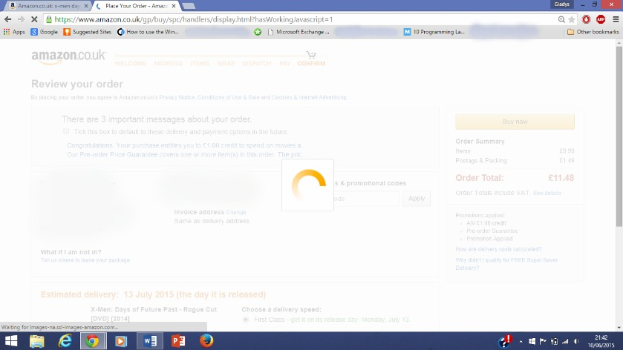
The first rule being visibility of system status, when carrying out a search on Amazon or by clicking items, or even when you are being taken to the page where you review your order, the way Amazon notifies users that they are processing your request is by having their signature loading screen with a wheel circling round and round until you have been taken to the directed page.
Match between your site and the real world, Amazon does this by allowing users to shop in all departments (book section, clothing, DVDs, electronics etc.) as if they are actually in a real store. They have a navigation pane that users can roll over and select which department they would like to shop in, being open to a variety of selections and even suggestions of what they could buy.
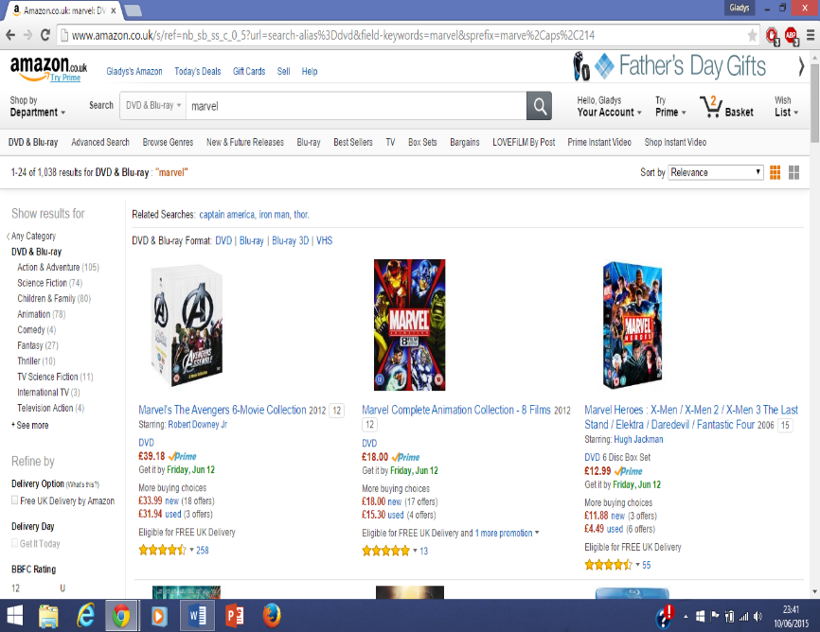
User control and freedom for users, when on the Amazon website can be for example if a user is carrying out a search, apart from the reults showing up, on the navigation pane it has in bold the category of which your search is within, so in this case, I have searched for a DVD, and in bold, the first category is “DVD & Blue ray”. On the page users are also able to choose if they would like to sort their searches by relevance or even by lowest price. This site gives users the freedom to roam about on their own terms until they have happily found the products they wish to buy.
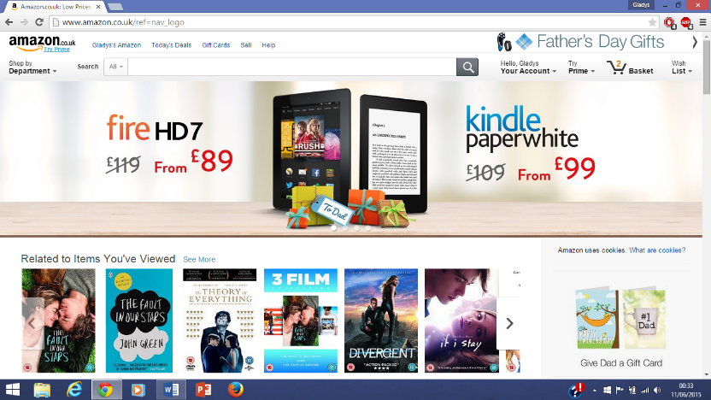
On ecommerce websites they should all have consistency and standards, meaning that (ecommerce sites similar to Amazon like Rakuten or Ebay) when using the website, it should be easy to learn and use, some tools should be the same, for example the search tool should do exactly the same thing; allow a user to search for whichever product they want to buy, or a button the user can click to view their basket and review the items they have chosen. Overall, the website should be easy to use so that customers can enjoy their user experience on the website in order to return to the website in the future and continue buying items from the site.
With error prevention, if a user were to accidentally add an item to their basket, they should be abble to remove that product so that they can avoid buying something they do not want and wasting money. Errors occur due to the fact that users do not look clearly at what they are doing or the instructions given were not understanderble. If errors like such happen, options like deleting items from the basket should be in clear view for the usser to select.
Recognition rather than recall refers to providing relevant information that the user needs. For example, if a user were to make a search on an ecommerce site, apaert form only having search relusts appear, suggestions of results that relate to what a user also shows up on the page, making things easier for users, if they were meant to have been searchijng something that has appeared in the suggestions.
Flexibility and efficiency of use increases interaction for more advanced internet users, for example, using shortcuts on browsers such as being able to zoom in and out of the page, or switch tabs quickly are things only more experienced computer users can do compared to someone that is new to computing. Accelerators are used to tailor shortcuts that are used frequently. On a webpage, these can be used for exmaple if you have chosen to save specific searches, being able to click and review them whether you want to pic up where you left off and want to continue looking for that searched item.
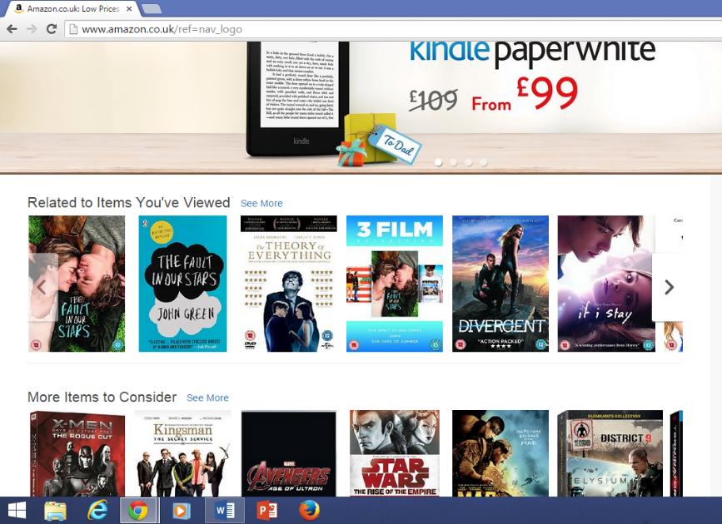
Amazon has an aesthetic and minimalist design. This means that the website is bold, it has a simple, yet sleek look, is attractive and easy to get around. A website should have all these factors in order to be taken seriously and should represent the website well. For example, on the Amazon homepage, as it has a single design and layout, it doesn’t contain unrelated images like logos from another site, it simply advertises products for users to check out, or lists related items to wht users have previously searched once on the website.
The website should also help users recognise and recover from errors such as if a user hasn’t filled in certain fields in an online registration form, the fields should have an asterix to identify to users which fields are important and has to be filled in. By having error messages appear alerting users where they have gone wrong, this prevents any errors (or even confusion) that could happen.

With help and documentation, this can be applied on websites that expect users to provide infomration which they may not be sure fill in, for example on an ecommerce website when a customer is about to purchase a product, they could be asking for the customer’s security code on their credit/debit card so that their transaction can be successful. Some people may not know where this is located, therefore by having a help icon next to the field where the customer can rollover for help to solve the problem, this makes things easier for customers as they do not have to go to certain lengths where they have to search on google to ask what a security code on a credit/debit card is.
So therefore, by using Jakob Nielson’s heuristics, it makes a user’s experience on a website much more easier and also more useful, meaning that they should have no problem in using the website and should be able to interact well with the site.

On the website that I have created using Weebly, I did not apply all of the heuristics, for example as it is only a portfolio, already the first principle isn’t applied. No where in my website has visibility of system status, unless a file is being downloaded from the website, the browser will show how long it will take for the file to download.
The second principle which is to match the website to the real world in a way applies to my website, for example, in the screenshot at the top you can see pages of units at the top that users can click on. This would refer to how a textbook is like, it has all the unit pages for readers to view and read. And with user control and navigaion, also in the image above, users are able to use the tabs as a navigation to get to any age they wish.
Websites that are like portfolios would definitely be the same, although they would not have the same layout, it should still be easy to get around the website. Consistency to standards may and may not be applied to this website as there isn’t much to do with the website but be able to click on different pages, and download files.
There is no error prevention needed on the website I have created, due to the fact that there shuldn’t be any errors users can come across whilst on the site, for example as mentioned you can only look through pages and download files.
With recognition rather than recall on the top of the unit pages on my website is a description of what I have learnt in the unit, giving a breif description of wht the unit is like, so that users will know what to expect when they come across the files on this page.
There isn’t much flexibility and efficiency of use to be done in the website I have created, due to the fact that it is a basic site. There could be a search bar that can be created for users to quickly search for files on the website and so that they could be able to save their searches, so that will be a consideration that has to be made in order to make the website more flexible for users.

As a person that is simple with designs, I have made my website to be as simple as possible. It hasn’t got too much colours, images, just simple look that users will be fine with and get used to and in some ways that relates to the reaon of my portfolio, showcasing my IT work.
Lastly, as mentioned above, there isn’t much of a way that users are able to have errors whilst using the website.so when it comes to Helping users recognise and recover form errors, this principle isn’t neccesarily required. Also help and documentation is a principle that may be used on the website, for example giving extra help on how users are able to download the files (even though it may be an easy process), but the aim of the website is to have visitors view the website as easily as possible, so adding in extra help can be considered.
Overall when it comes to my website it would be best to require all of Jakob Nielson’s heuristics although as not may of them are needed, having them in would be the best way to give users the best usability experience whilst on the website.

