Communication with the stakeholder
As the stakeholder has requested for a video to be made for the company WWE, in the email below, it demonstrates all of the stages that of the project that were requested, whether it was for me to create a design of the project, or having to include certain things into my project such as analysing the project correctly. The stages in which I went through whilst creating the project, was firstly directly after receiving the call from the stake holder, was to think of exactly how I was to carry out the project.
Stakeholder:
This is where the project begins. The stakeholder has just requested for me to create a video for the company WWE.
Me:
Stakeholder:
As I have accepted the request, I am now required to come up with such issues that could occur, issues to do with the end-user if they would not find the video satisfying, and so I had to reflect on that.

Me:
After coming up with a problem that could occur with my project, I have explained briefly what exactly could happen, such as people not being familiar with the company, and have briefly given an example in order to turn around the problem and resolve it.
Stakeholder:
As my email has been read by the stakeholder, and they have agreed to what I have come up with, I have now been asked how I have analysed my project, how I am basically going to carry it out and implement on it.
Me:
In my response to analysing my project, I have explained that I am firstly going to plan it, collect all resources that I need such as images, information and video clips that I would include in the project, who the video is targeted at, and how to meet their requirements, and also by deciding which software I am going to use for actually creating the video.
Stakeholder:
Of course before creating the video I would have to plan it out by making a design, and so this is what the stakeholder wants from me, a design of my project.
Me:
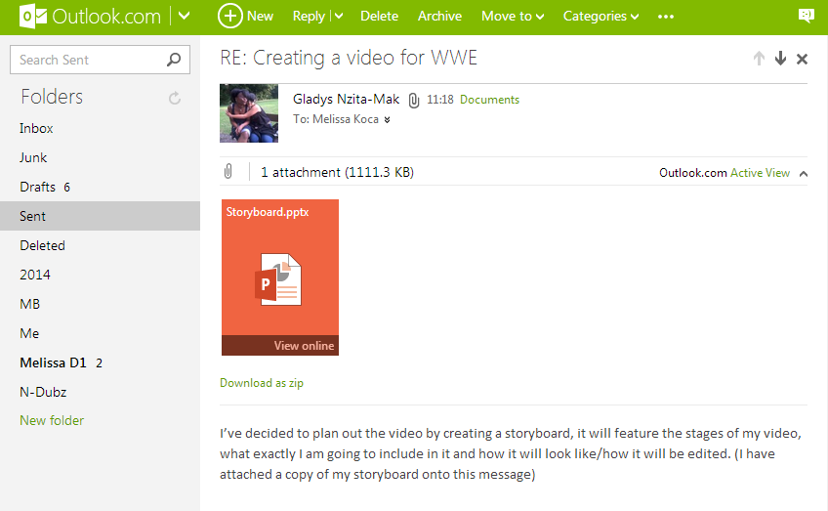
I decided to explain in what form I would be carrying out the design of my project – a storyboard of what will feature in the video. I then attached a copy of the storyboard onto the email so that the stakeholder can have an image of what my video would turn out like.
Stakeholder:
Happy with the design, the stakeholder then asks how I have used it to implement on the video that I created.

Me:
Here in this response I have noted down that I have used the design to know exactly what to put where, for example where to put music, or what information I should include. I then stated down that I would be using the software ‘Windows Live Movie Maker’ to create the video, and so it will allow me to edit the video, add transitions, music and other clips in the video, and with the storyboard, I know exactly where and when to add in all of these resources.
Stakeholder:
I have now been asked how exactly I have tested my project.
Me:
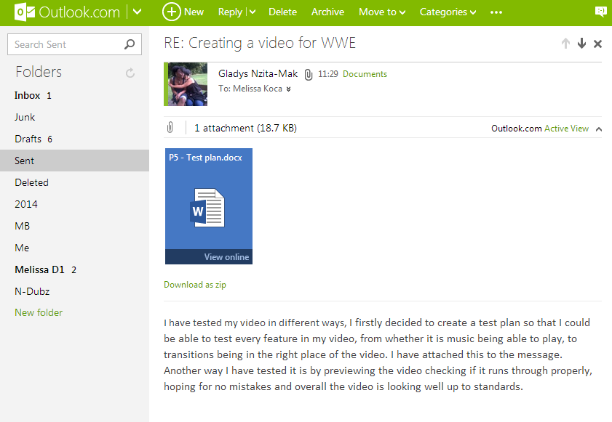
I have stated that when it came to testing my video that I have tested it in two ways, a test plan (which I have attached to the email) and simply just playing back the video, spotting where exactly there are mistakes and going back to edit them if there are any.
Stakeholder:
The stakeholder has received my test plan and has replied that it is impressive.

Me:
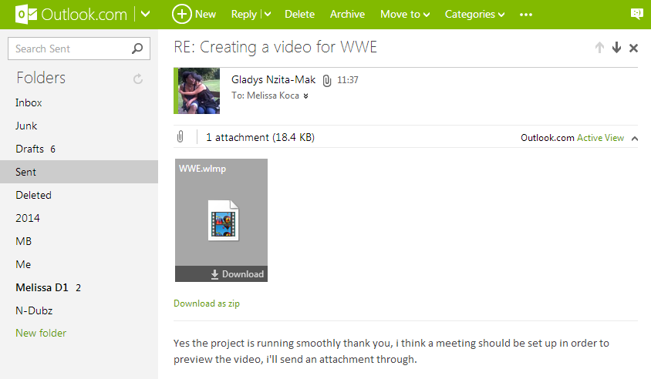
I have decided that I should set-up a meeting so that the stakeholders can be able to discuss my video whether it is good enough to be seen by end-users, and whether it has met their requirements, therefore I have sent them a copy of my video.
Stakeholder:
Finally, I have been asked how exactly I have evaluated the video I had been working on.

Me:
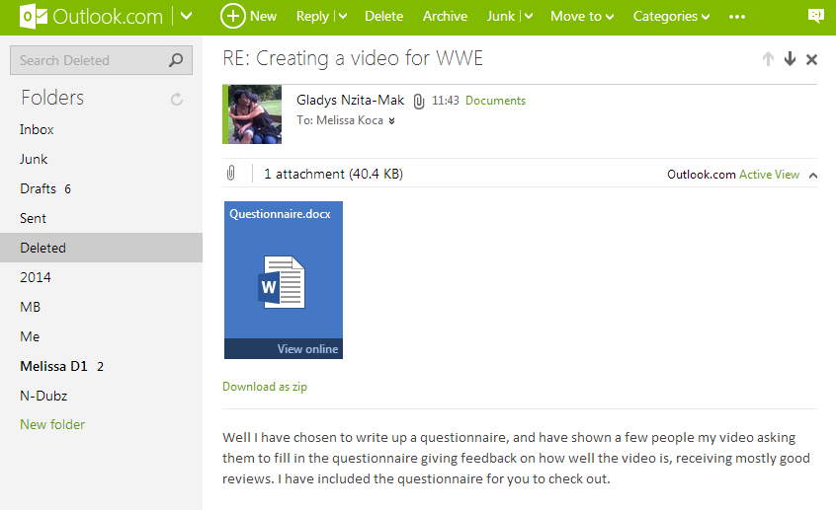
The way in which I have evaluated the video I created, was by doing up a questionnaire allowing people to judge my video based on the questions proposed. I have attached it onto the email so that the stakeholder can get an idea of what questions were asked.
Stakeholder:
Overall, although it did take quite some time creating and managing the project, I have managed to complete it. Using a lifecycle to manage out my project has worked successfully, I had Identified the project, analysed it, designed, implemented, tested and evaluated my project, and have overall produced a great video. Finally the stakeholder has congratulated me on my hard work on managing my project.

